Article

IoT monitoring of tree ecosystem services in urban green infrastructures: possibilities and challenges

Victor Matasov 1,*, Alexey Yaroslavtsev 1,7, Giovanna Sala 1,2, Olga Fareeva 1, Ivan Seregin 1,7, Luca Belelli Marchesini 1,3, Simona Castaldi 1,4, Viacheslav Vasenev 1 and Riccardo Valentini 1,5,6

1 Department of Landscape Design and Sustainable Ecosystems, Agrarian-Technological Institute, RUDN University, Miklukho-Maklaya str., 6, 117198, Moscow, Russia;

2 Department of Agricultural and Forestry Science, University of Palermo, Viale delle Scienze, Ed. 4, 90128 Palermo, Italy;

3 Department of Sustainable Agro-ecosystems and Bioresources, Research and Innovation Centre, Fondazione Edmund Mach, San Michele all’Adige, Italy;

4 Department of Environmental, Biological and Pharmaceutical Sciences and Technologies, Campania University “Luigi Vanvitelli”, Via Vivaldi 43, 81100 Caserta, Italy;

5 Department for Innovation in Biological, Agro-Food and Forest Systems, University of Tuscia, Via S.M. in Gradi n.4, 01100 Viterbo, Italy;

6 CMCC Foundation, via Augusto Imperatore, 16, 73100 Lecce, Italy;

7 Department of ecology, Russian Timiryazev State Agrarian University, Moscow, Russia;

**\*** Correspondence: matasov-vm@pfur.ru;

Received: date; Accepted: date; Published: date

**Abstract.**

Urban green spaces play an essential role in the sustainable functioning of urban ecosystems and provide the most important regulating and cultural ecosystem services. Meanwhile cities are entering a new age of widespread data collection, processing, and utilization in urban decision-making. It is necessary to expand the uses of digital and computing technologies to green infrastructure management, as it is a crucial component for human well-being under the rapid urbanization.

The Bolotnaya square – small green area situated on the island Balchug in the center of Moscow – was chosen as a study site that represents urban green infrastructure under the high influence of urban heat island and high level of anthropogenic load. For real-time monitoring sixteen TreeTalkers devices that provide data on physiological conditions of a single tree were installed to describe different species in their local conditions. All measurements were conducted from 1 July to 31 November with 1.5 hour time resolution. We used R programming language for all data processing. To move from parameters of trees functioning to provided ecosystem services we relied upon several indicators related to climate, air quality and water regulation.

Our results show that the average tree in Moscow center during investigated period reduced extreme heat on 2℃ degree due to the produced shade, cooled down the surrounding area by consuming 4900KWh of energy, transpired 160 mmof precipitation water, sequestered 12 kg of atmospheric carbon and absorbed 4.5 kg of PM10. But the values of the monitored processes vary spatially and temporally when considering different tree species (up to five-ten times), local environmental conditions, the seasonal course of weather factors. Thus, it is crucial to use real-time monitoring data to understand deeper the processes in urban forests. There is a new opportunity of applying IoT technology not only to measure trees functionality through fluxes of water and carbon, but to establish a smart urban green infrastructure management providing ecosystem services indicators.

**Key words**: Ecosystem services, Ecological engineering, Green infrastructure, Real-time monitoring, Smart cities, Sustainability, TreeTalker, Trees, Urban forests.

**1. Introduction**

Urbanization is increasing on a global scale, and today more than half of the world's population lives in cities and more than two thirds are expected to live in cities by 2050 (Dye, 2008). Concentration of population in cities plays a significant role in fostering economic development and encouraging innovation due to economies of scale (Bettencourt et al., 2007). In addition this process may also have negative effects on many aspects of human well-being, including increasing crime rates (Bettencourt et al., 2007) and growing health risks (Frumkin, 2003; Lederbogen et al., 2011). Moreover, it was shown that urban areas significantly contribute to climate change and global carbon emissions, ecosystem degradation and biodiversity loss on a global scale (Grimm et al., 2008; Seto et al., 2012). It is well-known that people living in urban areas depend on natural ecosystems not only within the city limits, but also beyond the urban area (Bolund and Hunhammar, 1999) thus demands on natural capital and ecosystems services keep increasing steadily (Guo et al., 2010; Krausmann et al., 2018).

The ecosystem services (ES) concept, which emerged from ecological economics in the 1990s, allows to understand and explain human-environmental interactions complexity and it is useful landscape planning (Vihervaara et al., 2019; Wilkinson et al., 2013). It is widely discussed that ES concept could be used as a new Esperanto (Spyra et al., 2019) because of its communicative power in participatory planning processes (Haaren et al., 2019; Opdam et al., 2018). But such comprehensive planning approach requires planners to assess and value nature’s contributions to the human well-being (Gómez-Baggethun and Barton, 2013; UNEP, 2010), especially in a cities as a coupled human-environment systems (Wu, 2013). The concept of ES and its application to urban environments were addressed by major initiatives like the Millennium Ecosystem Assessment and The Economics of Ecosystems and Biodiversity, and have gained increasing attention in literature (Bolund and Hunhammar, 1999; Haase et al., 2014; Kremer et al., 2016) and in a policy debate on green infrastructure (Burkhard et al., 2018). However, ES concept might be too complex and sometimes does not meet the real world and requirements for planning applications, and even might be misinterpreted in practice (Czúcz et al., 2018; La Rosa et al., 2016; Luederitz et al., 2015). It is common situation when decision-makers pay attention to visible and directly usable ES, which are mainly provisional and cultural ES and underestimate the value of regulating and habitat ES (Mascarenhas et al., 2016; van Oudenhoven et al., 2018; Wissen Hayek et al., 2016).

Urban green infrastructure (UGI) play an essential role in the sustainable functioning of urban ecosystems and provide the most important regulating and habitat ecosystem services such as carbon sequestration, microclimate formation, pollution and dust reduction in atmospheric air, water balance control, wildlife habitat, wind and noise reduction, etc. (Andersson et al., 2014; Gómez-Baggethun and Barton, 2013; Lovell and Taylor, 2013). The magnitude of the ES provided depend on the characteristics of UGI, such as vegetation type, age, structure and management practices, which is important compare to natural ecosystems. This may cause a trade-off between which service is maximized (Bodnaruk et al., 2017), or between ecosystem services and disservices (Speak et al., 2018; Teixeira et al., 2019) and could be a reason for cost-benefit analysis (Song et al., 2018; von Döhren and Haase, 2019). There are several studies that assess ES in different types of UGI (Blanusa et al., 2019; Lovell and Taylor, 2013; Nowak et al., 2006), in areas with the same typology but different types of management (Lilly et al., 2015; Schwilch et al., 2018) or in different types of vegetation within the same area (Mexia et al., 2018). Several types of models identify ES via proxies, typically land-use/cover, based on expert knowledge and causal relationships (Neugarten et al., 2018). Urban ES assessing presents a special case due to the high, fine-resolution spatial heterogeneity of these landscapes that could lead to high mapping error (Zhao and Sander, 2018). That is why to better understand the ES provided by UGI researchers conducted direct measurements of different processes (Nowak et al., 2006; Nowak and Crane, 2002), and its modeling (Lin et al., 2019; Rötzer et al., 2019) on a tree-level, which yielded in wide spreading use of software and tools, such as i-Tree model (<http://www.itreetools.org>).

Our understanding of the relationships between functional fluxes in ecosystems and services they provide is still very incomplete (Drobnik et al., 2018; Van Reeth, 2013). To overcome this high complexity in human-environmental systems scientists use ecological indicators that generally are variables that provide aggregated information on certain phenomena (Müller and Burkhard, 2012). For the ES assessment the importance of developing appropriate indicators has been recognized (Burkhard et al., 2018; van Oudenhoven et al., 2018) and many ES indicators have been developed, applied, tested and reviewed (Gómez-Baggethun and Barton, 2013; La Rosa et al., 2016; Wissen Hayek et al., 2016). ES indicators need to be relevant to specific purpose (e.g. to reflect difference in land management - van Oudenhoven et al. 2012) or component (e.g. soils - Andrea et al. 2018; Drobnik et al. 2018) or spatial-temporal scale (Aalders and Stanik, 2019; Norton et al., 2016) to avoid uncertainties from that side, but at the same time ES indicators should inform decision making (Czúcz et al., 2018; Willcock et al., 2016). It’s completely clear for decision-makers that “you cannot manage what you do not measure”, thus these indicators should be linked to measurable policy targets and should help to monitor policy progress. And from another side we see a growing interest from citizens to the widespread measurements of the environmental conditions they are living in (Njue et al., 2019; Schröter et al., 2017), so it is also necessary to create clearly understandable indicators for involving people. Furthermore, technologies of observation, modeling, computing and even acting in a new Industry 4.0 world increased rapidly in recent years (Nitoslawski et al., 2019).

The widespread integration into the urban environment of Information and Communication Technologies (ICTs) and Internet of Things (IoT) tools makes our cities “smart” (Albino et al., 2015). Smart technologies are already being applied in environmental management. The species and structure of individual trees were mapped and assessed with remote sensing, aided by machine learning (Alonzo et al., 2014). Forest regeneration was assisted by drones or unmanned aerial vehicles (UAVs) through surveying, fertilizer spraying, and precision aerial seeding (Elliott, 2016). Wireless sensor networks have been deployed in greenhouse settings to measure and regulate environmental parameters (Bauer et al., 2019; Mesas-Carrascosa et al., 2015). Acoustic sensors were used to assess the urban noise pollution (Farina et al., 2014; Mydlarz et al., 2019). The huge data collected through these technologies provide more insight into the UGI and can be used in analysis, modeling, and prediction (Kitchin, 2014). Traditional monitoring methods do not allow assessing the state of UGI with the spatial-temporal resolution needed for the diagnosis of stressful situations and for decision-making on the management and development of an urban environment. Such new smart digital technologies can be used as tools to improve the human well-being through balancing the ES provided by UGI. The use of wireless network sensors and data loggers can provide information about environmental parameters at a local scale and its visualization in real time (Kitchin, 2014; Nitoslawski et al., 2019).

The aim of this work was to show the possibilities and discuss the challenges of real-time tree-level monitoring of ecosystem services in urban conditions. We focused on next objectives:

1) test the real-time monitoring technology by measuring trees functional parameters in different conditions,

2) justify the indicators that can be useful to interpret measurements in terms of ecosystem services,

**2. Materials and Methods.**

2.1. Study site and installations

With a population of over 12 million people, Moscow is the largest metropolis in Europe. The territory of the Moscow metropolis is located in the center of the East European Plain and has a temperate continental climate. The typical vegetation, including species characteristic of the South Taiga zone, has been preserved mainly in specially protected natural areas, while a significant part of green infrastructure is represented by introduced species: linden, maple, willow, ornamental forms of trees and shrubs. The New Moscow Development Project, adopted in 2012, has started active urbanization on an area of more than 1,500 km2, the impact of which on soils and ecosystems is already visible (Vasenev et al., 2019) and will only increase in the future.

The study was conducted in the Bolotnaya square in city of Moscow, Russia. This square is a small green area (370 m length and 120 m width) situated on the island Balchug ( Figure 1), 600 m to the south from the Kremlin. The site is located only 700 m to the west from Balchug meteorological station that provided data each 3 hours. According to the Köppen climate classification, the climate in this area is a humid continental climate. The daily mean temperature varies between min °C in month and max °C in month, the amount of precipitation is rather high with an amount of 707 mm/year, mainly in the summer months.

Study area represents a typical urban green infrastructure under the high influence of urban heat island and high level of anthropogenic load. The main works on its improvement (tree planting) were completed by 1948.

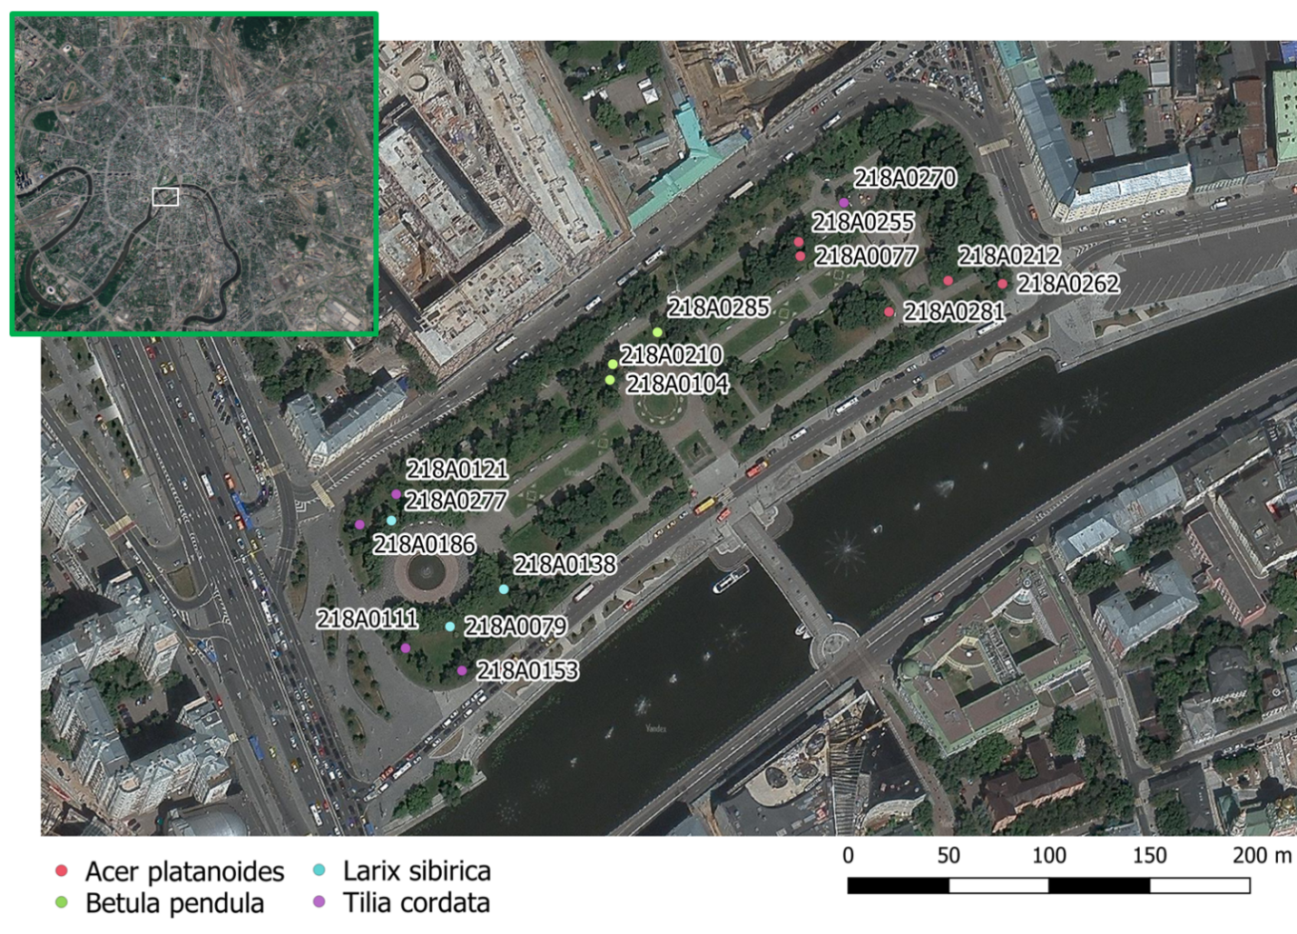

Figure 1. Study area.

Sixteen TreeTalker+ (TT+) devices were installed on trees: 5 on *Acer platanoides* (average DBH 38.7 cm), 3 on *Betula pendula* (average DBH 21.8 cm), 3 on *Larix sibirica* (average DBH 32.1 cm) and 5 on *Tillia cordata* (average DBH 34.1 cm). At onset of installation, all trees were characterized by height, diameter, age group, VTA score, (ranging from 1 (healthy conditions) to 7 (severe decline) and standing type (see annex 3).

The TreeTalkers devices (TT+) (Nature4.0 BC URL: www.nature4.org, Valentini et al. 2019) are microprocessor based IoT platform built around the ATMEGA328 chip, equipped with a LoRa transceiver for radio transmission to a central gateway which collect the individual tree data and send to cloud using GSM/GPRS technology. The TT+ sensors are able to measure: 1) the sap flow density, using a transient thermal dissipation methods based on an heating/cooling cycle of 10minutes every 1.5 hour (Do et al., 2018), 2) the light transmission spectra through the canopy in 12 spectral bands , using 2 spectrometers (VIS and NIR), 3) diameter growth with an optical IR pulsed device, 4) Stem position and oscillation in 3 axis with an on board accelerometer. In addition air temperature and humidity is recorded at the single tree level. Specifications are listed in Table 1.

Table 1. Measured parameters according to TT+ specification.

|  |  |  |
| --- | --- | --- |
| **Sensor** | **Range** | **Accuracy** |
| Accelerometer | 0-360° (0-8g) | ± 0.01° |
| Diameter growth sensor | 0-1 cm | ±200 µ |
| Temperature probes | -40 ÷ +40 °C | ±0.1 °C |
| Stem humidity probe | 0 – 100% | ± 2% v/v |
| Visible Spectrometer | 400-700 nm | ± 5 nm peak  ± 20 nm HBW  (450,500,550,570,600,650 nm) |
| Near-Infrared Spectrometer | 700- 900 nm | ± 5 nm peak  ± 10 nm HBW  (610,680,730,760,810,860 nm) |
| Air and humidity sensor | -10 ÷ +85  0-100% | ± 0.5 °C  ± 5% |

A reference device TT+ (TT-R) was mounted outside of the tree canopies to collect climate data and incoming solar radiation reference spectra. On individual trees, the devices were placed at a height of 3 m from the ground on the north side of the trunk and the solar powered batteries - on the south side (fig. 2). The 3 m height was chosen to reduce the risk of damage or theft of devices. All measurements were conducted from 01 July till 31 November with 1.5 hour temporal resolution.

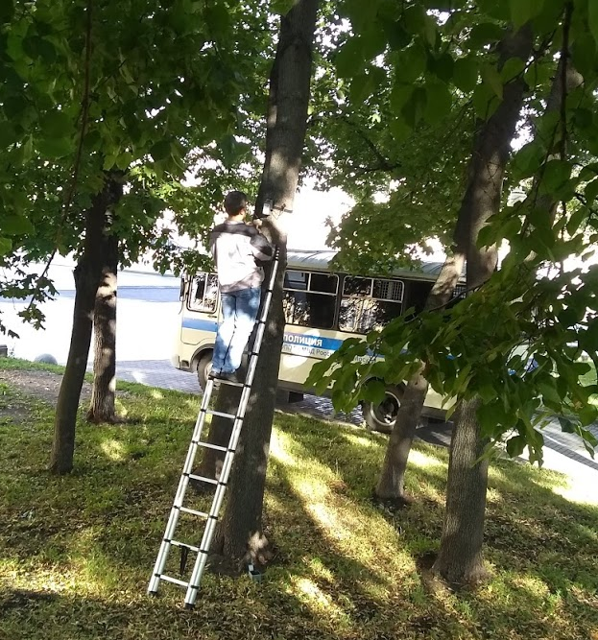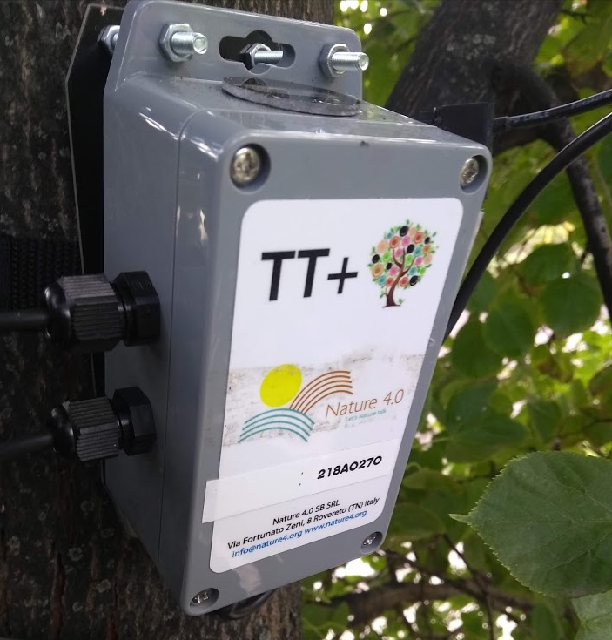

Figure 2. Process of mounting TT+ on a tree and its image.

2.2. Choice of ES Indicators.

There is a wide range of existing ES indicators, thus we have tried to choose from existing literature (Andersson-Sköld et al., 2018; Gómez-Baggethun and Barton, 2013) the ones that can be directly estimated by our measured parameters. The ES indicators and the relative measured variables, including algorithms references are shown on table 2. Direct measurements (like air temperature or relative humidity) gave us an opportunity to calculate ESI without any additional assumptions. However all the ESI that is labeled as “indirect” required us to introduce some adjustment factors or assumptions. One of the best “indirect” predictor of ES is the Leaf Area Index of the Tree since many ESI can be estimated by the amount of leaf area. For the purpose of this paper we have monitored LAI in real time by using the device 2 spectrometers and we present particulate adsorption as an example of usefulness of LAI indicator indirect use.

Table 2. Indicators of ES, provided by urban trees and potential measuring quantity by sensors

|  |  |  |  |  |  |  |
| --- | --- | --- | --- | --- | --- | --- |
| **ES group** | **Type of ES** | **Indicator** | **Sensor** | **Type of equation** | **Units** | **Key references** |
| Global Climate regulation | Carbon sequestration | Tree growth rate | IR growth sensor | Indirect | kg C | (Gratani and Varone, 2006; Lindén et al., 2020; Nowak and Crane, 2002) |
| Local Climate regulation | Climate comfort regulation | Air temperature | Thermo-hygrometer sensor | Direct | C degrees | Land surface temperature and climate comfort level (Krayenhoff et al., 2020; Marando et al., 2019; Morakinyo et al., 2020) |
| Humidity | Thermo-hygrometer sensor | Direct | % | Humidity control (Chen et al., 2019; Moghbel and Erfanian Salim, 2017) |
| Wind velocity | Spectrometer | Proxy  ~LAI | m s-1 | Wind comfort level (Hefny Salim et al., 2015; Kang et al., 2020; Lee et al., 2010) |
| Energy balance regulation | Latent energy via transpiration | Sap flow sensors | Direct | W m-2 | Exergy (Puzachenko et al., 2013, 2014), Energy balance (Krayenhoff et al., 2020; Moser et al., 2015; Rahman et al., 2020) |
| Water regulation | Run-off mitigation | Evapotranspiration | Sap flow sensors | Direct | l hr-1 or mm | (Chen et al., 2019; Marchionni et al., 2019; Urban et al., 2019; Zölch et al., 2017) |
| Rain buffer | Spectrometer | indirect  ~LAI | % | Rainfall buffer (Pereira et al., 2009; Smets et al., 2019; Valente et al., 2020) |
| Air quality regulation | Particulate adsorption | PM removal | Spectrometer | Indirect  ~LAI | g m-2 | (Hirabayashi et al., 2012; Nowak et al., 2018, 2006; Sæbø et al., 2012) |
| Gas regulation | Gaseous pollutants removal | Spectrometer | Indirect ~LAI | g m-2 |

*2.2.1. Carbon sequestration*

Carbon sequestration assessment was based on IPCC 2003 approach utilizing biomass expansion factors (BEF):

|  |  |
| --- | --- |
| ΔC = [ΔV * BCEF] * (1 + R) * CF, | (1) |

where ΔV is tree stem volume (m3); BCEF is Biomass Conversion and Expansion Factor obtained using this formula BCEF = BEF * D where BEF is biomass expansion factor to obtain the total above-ground biomass and D is a is density of the wood (kg/m3); R is ratio between below-ground and above-ground biomass; CF is the carbon fraction of the dry mass (conventionally equal to 0.5

as suggested by IPCC 2003).

The BCEF and R was taken from literature according to species and age of the tree (Schepaschenko et al., 2018), CF (biomass conversion into carbon) was taken as 0.5. Trunk volume (V) was calculated using height measured directly in field and basal area increment (BAI according to LeBlanc, 1992).

|  |  |
| --- | --- |
| $BAI=\frac{π}{4}\left[{DBH}^{2}\right.\left.{-(DBH-2w)}^{2}\right]$, | (2) |

where *w* is trunk diameter expansion measured in real time with TreeTalker+ IR distance sensor. Stem shape coefficients for different species have been taken into account for the estimation of the trunk shape in the final calculation of biomass increment.

*2.2.2. Climate regulation via air temperature and humidity*

We have used direct measurements of temperature and humidity changes based on the difference between data form thermo-hygrometers of individual TT, measuring climate parameters at 3 m height under the crown space and TT-R (reference outside station). Temperature and humidity measurements were taken by the TT device with a measuring cycle of 1.5 hours as for all the other parameters.

*2.2.3. Water fluxes and energy consumption through transpiration*

The transpiration rate of whole plants is closely approximated by the sap flow rate in the main stem or trunk. We implemented in the TT platform the Thermal Dissipation method, firstly developed by Granier (1985). Granier original method is based on the dissipation of a heated probe in relation to a reference one in proximity (about 10 cm in our case), with continuous heating. The need of reducing of energy consumption in field operations have raised up modifications of the thermal dissipation method to include the possibility to use heating and cooling cycles, which reflect in a better accounting of thermal gradients and at the same time reducing the power requirements. In this experiment we have used the approach of Do et al. (2011, 2018), with a heating cycling of 10 minutes, while data are sent every 90 minutes to the server. The heated and reference probes of TT+ are installed into the tree trunk at the vertical distance of 10 cm. The probes have a diameter of 2.5mm each and are installed at the depth of 2.5cm. The TT+ heat dissipation probe is installed on the northern side of the trunk at the 3.5m height and is well protected from direct sun heating by the canopy. The sap wood area for each tree was assessed by collecting 2 stem wood cores taken from each tree and sapwood determined by translucence optical evaluation. Sap flow was calculated with the assumption that the whole trunk sapwood area was conducting water. It was assumed that daily transpiration is equal to daily sum of sap flow. Transpiration was normalized to each tree canopy area and compared with precipitation from closest meteorological station.

The energy absorbed by tree for transpiration was calculated on the basis of the equation:

|  |  |
| --- | --- |
| L= T , | (3) |

where  is energy spent in transpiration ( the latent heat for vaporization of water = 2264.705 KJ/Kg), T – transpiration, which was assumed equal to sap flow.

As additional indicator we have used the potential runoff calculated by a simplified hydrological balance, assuming that precipitation input is partitioned between transpiration and runoff:

|  |  |
| --- | --- |
| R= P-T, | (4) |

where R is runoff, P is precipitation and T transpiration, using mm as unit of measure for all the processes.

*2.2.5. LAI*

There are a lot of different methods and protocols to estimate LAI (X. Wang et al., 2019; Yan et al., 2019). According to Monsi and Saeki (1953) light transmission through canopy as porous media can be treated according to the Beers law. In this way LAI can be estimated by the extinction of photosynthetic light radiation through the canopy (Neinavaz et al., 2016). Photosynthetically active radiation was measured above and below canopy (with TT-R and TT+ spectrometers, respectively). Since the light is blocked also by woody components of canopy (i.e. branches and twigs), the extinction of light profile gives the PAI (Plant Area Index) as follow:

|  |  |
| --- | --- |
| $PAI=LAI+WAI= -\frac{\ln{(\frac{{PAR}_{TT+}}{{PAR}_{TTR}})}}{k}⁡$. | (5) |

PAI consists of wood area index (WAI) and leaf area index (LAI). Assuming that WAI is constant throughout vegetation period and LAI = 0 after defoliation (second part of October and November), WAI for each tree was calculated as mean PAI of November*.* Light extinction coefficient k was calculated per each species utilizing LAI measurement with hemispherical photo done with Kodak PIXPRO SP360 and Hemisfer software (Thimonier et al., 2010).

*2.2.6. Particulate adsorption*

Dry deposition of solid particles on canopy was calculated according to i-Tree Eco Dry Deposition Model (Hirabayashi et al., 2012):

|  |  |
| --- | --- |
| Pads=Vd*C $${ Vd = V}_{dPM10avgB}∙\frac{WAI+LAI}{WAI+{LAI}_{PM10}}$$ $${ V_{d,min} = V}_{dPM10min}∙\frac{WAI+LAI}{WAI+{LAI}_{PM10}}$$ $${ V_{d, max} = V}_{dPM10max}∙\frac{WAI+LAI}{WAI+{LAI}_{PM10}},$$ | (6) |

where C is the PM10 concentration (g m-3), Vd the velocity of deposition (m s-1), LAIPM10  the leaf area index for pollutant deposition (m2m-2) and VdPM10max,VdPM10avg,VdPM10min  – maximum, average and minimum deposition velocity for PM10 – 0.0064 ms-1, 0.0025 ms-1, 0.01 ms-1, respectively. Values were multiply by canopy area to show adsorption per individual tree. Pollutant concentration was obtained from nearby open access pm10 sensors via sensor.community web portal in Moscow (<https://sensor.community/en/>).

2.3. Data processing.

Data collection with TreeTalker+ devices is organized according to the following scheme. All types of devices (TT+ and TT-R) made measurement every 90 minutes, stored data in internal memory, and then according to predefined time window transmitted data to the gateway (TT-cloud)device via Low Power Wide Area Network (LoRa) wireless networking protocol. TT-cloud device is a gateway, which purpose is to collect data from all TT devices on site, store it and then transmit it to online database via WiFi or wireless mobile networks.

All remote data were collected and processed with R computing language (R Core Team, 2020). Field data was organized in a table and added to computation on early stages of processing. All weekly measured parameters were filtered by excluding 3 sigma (standard deviation) data. Filtered data was linearly interpolated. Data from TT devices didn’t have gaps more than three days (due to some battery problems). Data were filled with data from trees with closest parameters (species, trunk diameter, height, canopy size, position on site).

**3. Results and discussion.**

* 1. Carbon sequestration.

Carbon sequestration is the result of continuous diameter increment across the season and relative biomass accumulation was calculated using equation (1). The growth dynamics show biomass increase till the end of September (around 260 day of a year) due to the warm autumn (fig. 3). Birch growth rates decreased two weeks later than others, with less variability across individuals, possibly because of more uniform young age. Betula growth rates range form 2.19 to 2.79 Kg C per tree along the season and they represent the lowest values among the investigated trees. Acer growth rates range from 8.35 to 15.3 Kg C per tree along the season with a moderate variability. Linden growth rates are slightly lower than Maple ranging from 1.76 to 6.27 KgC, showing a marked individual variation. Larch trees represent show similar growth rates with values ranging from 4.95 to 7.66 kC per tree.

In total the average accumulated carbon (during half of the vegetational season) per tree for the investigated species are11.58±1.47 Kg C (*Acer platanoides*, ± standard error ), 1.5±0.15 Kg C (*Betula pendula*), 6.03±1.31 Kg C (*Larix sibirica*), 10.89±2.89 Kg C (*Tilia cordata*).

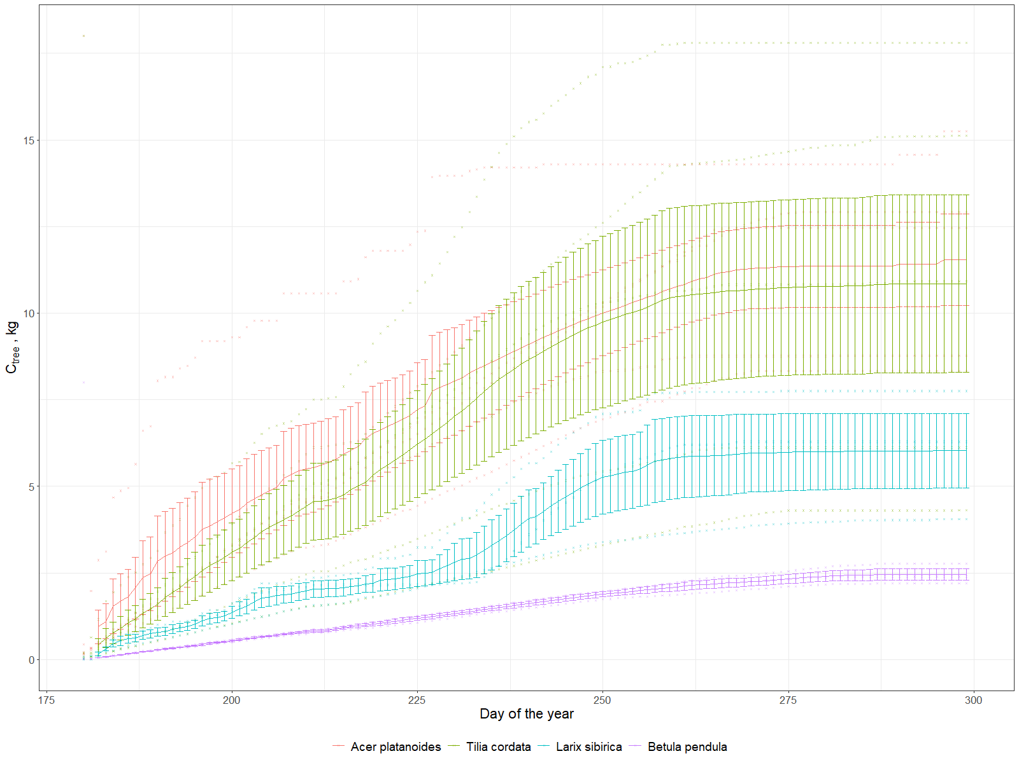

Figure 3. Cumulative grow of stored carbon for species, whiskers denote standard error.

We have furthemore compared the seasonal growth rates with the mean annual increment derived by the total estimated biomass, derived by the biomass expansion factors equation and divided by the tree age. Notwithstanding the uncertainty on age of about 5 years, the current increment estimated by the diameter optical growth sensor is comparable with the annual mean increment. In particular the former is higher as usually reported for tree ages before full maturity..

In general our knowledge of urban tree carbon dynamics, including the balance of growth, mortality, and planting rates is quite data limited (Nowak et al. 2004). Although the carbon stock of the urban green is smaller compared to natural forests, the storage capacity is considerable high (Moser et al., 2020). Growth rates of urban trees may be accelerated by the heat island effect, as result of increasing temperature, longer growing season and potentially higher N deposition, as it was shown by Pretzsch et al. (2017). The observed diameter growth for the different species, although is rather variable across individuals, are consistent with the existing literature, showing for *Picea* and *Birch* a range of 1-3 mm of annul growth (Augustaitis et al., 2018, 2015) in the same age range. Conversion of diameter growth in biomass and hence carbon sequestration is very much related with the BEF coeffcients which we have derived by (Schepaschenko et al., 2018), specifically for the Russian environment. One of the most comprehensive study on urban tree carbon sequestration is the one of Nowak et al. (2013) across a wide range of US cities. These authors showed an average annual net carbon uptake per tree of about 0.226 m-2 year-1. Scaling larch trees carbon sequestration per unit of crown area we obtain an average value of 0.14±0.04 kg C m2 per half of vegetation period, which is the closest result in relation to Nowak et al., while for broad leaved species this paramater was more than two times higher (with max of 0.48±0.14 kg C m2 per half of vegetation period for *Acer platanoides*). Although is difficult to compare our data with existing annual growth rates, due to the lack of full season data coverage (about 4 out of 6 months) our data show a reasonable consistency with inventory data and existing literature, but more importantly they confirm the possibility to monitor in real time carbon sequestration as one of the most significant ecosysem service of urban trees.

* 1. Air Temperature and Humidity control.

The local climate control from ecosystem service perspective is the mitigation of extreme temperatures and providing comfort urban microclimate. In figure 4 the diurnal difference mean changes of temperature between the reference station and the space under the tree crown is presented as mean monthly day, for the investigated species. During the day the temperature difference is maximal, peaking on early afternoon in July, August and September, with the contrasting difference of October when the dynamic is reverted. During the day trees are cooling the surrounding air, showing an effect up to about 2°C degrees with the external temperatures. In October all the species show a warming effect at mid of the day, on the same order. An opposed behavior is recorded for nighttime periods where usually during summer months trees are slightly warmer than the surrounded air. In October they show a cooling effect in the night.

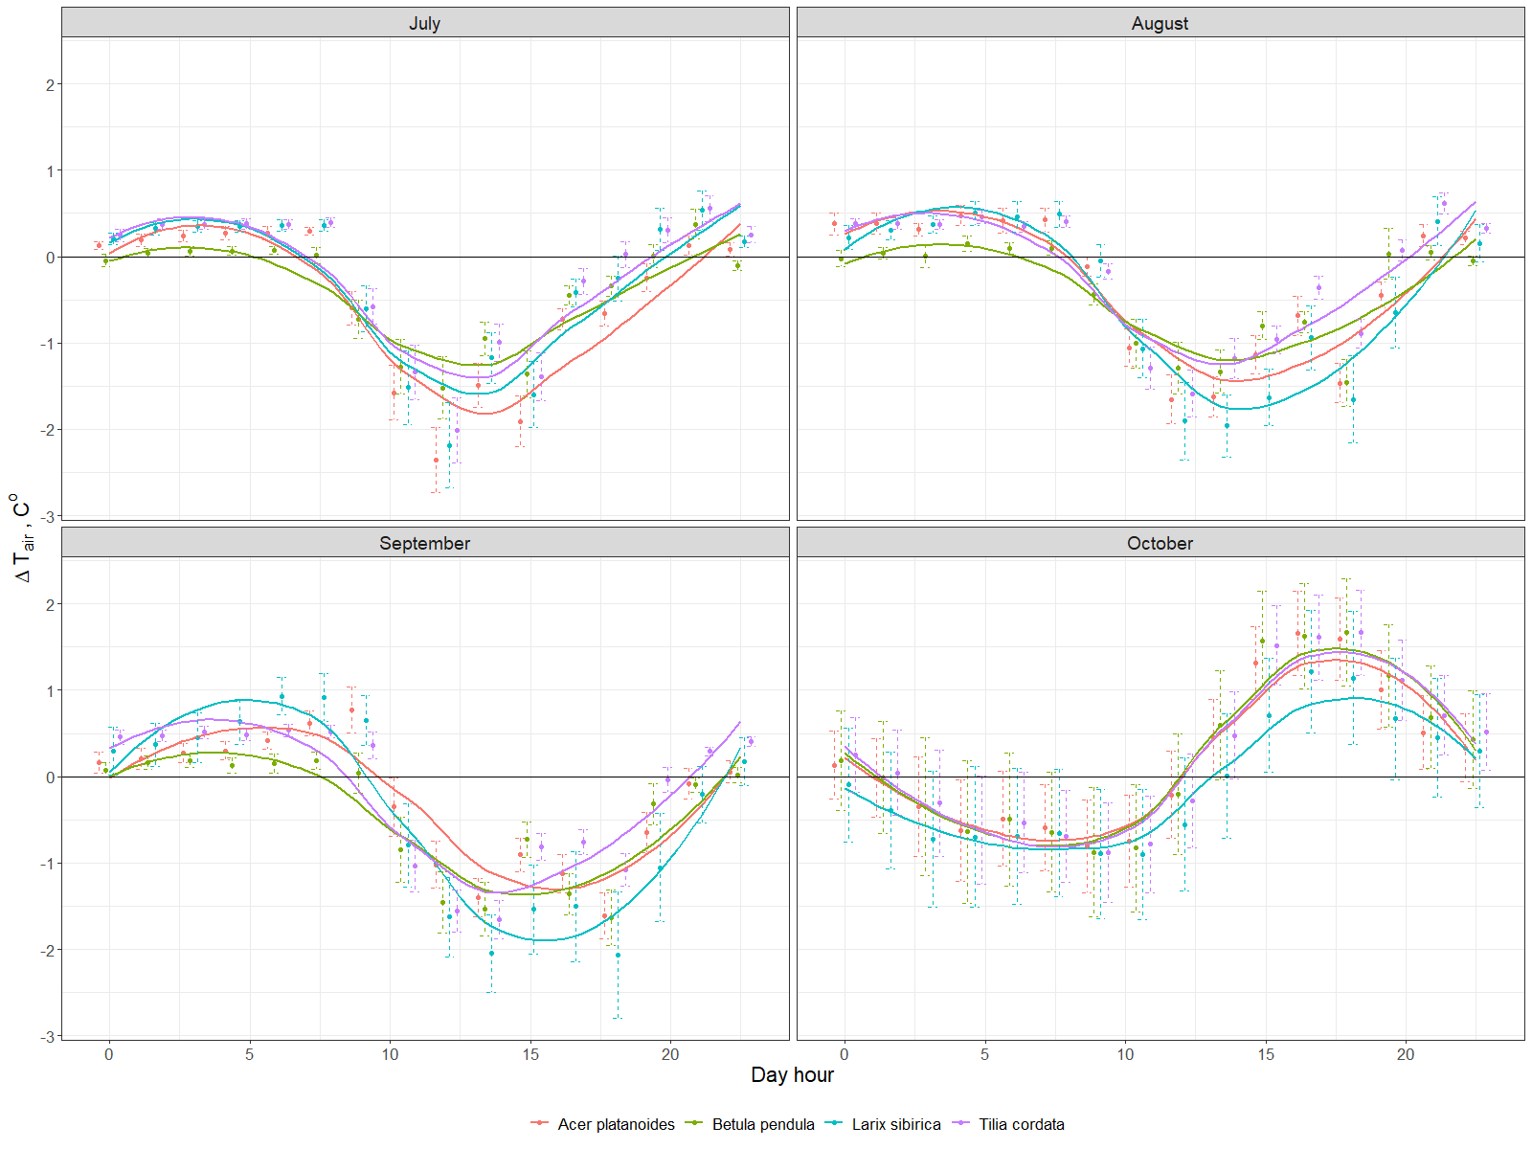

Figure 4. Diurnal differences mean changes of temperature by month averaged for all the investigated species

The average differences between the air relative humidity under and outside of the canopy were not more than 20% (annex 1). During daytime trees made air more humid, while during nights they reduced humidity. There were no seasonal changes through months, even no significant difference between species. We can only see the typical sinusoid line with delay in time as a result of transpiration process.

Another important effect of trees is the mitigation of climate extremes. For this purpose we have estimated the daily differences between maximum and minimum temperatures of the reference station and the individual tree recording (fig. 5). While temperature amplitudes outside of the canopy (the black line) reached a maximum of about 10°C degrees in August, under the canopy this amplitude was 3°C degrees lower. All the species showed similar dynamics through the investigated period, but under the larch temperature extremes were more similar to the reference station both during summer and particularly during fall after defoliation.

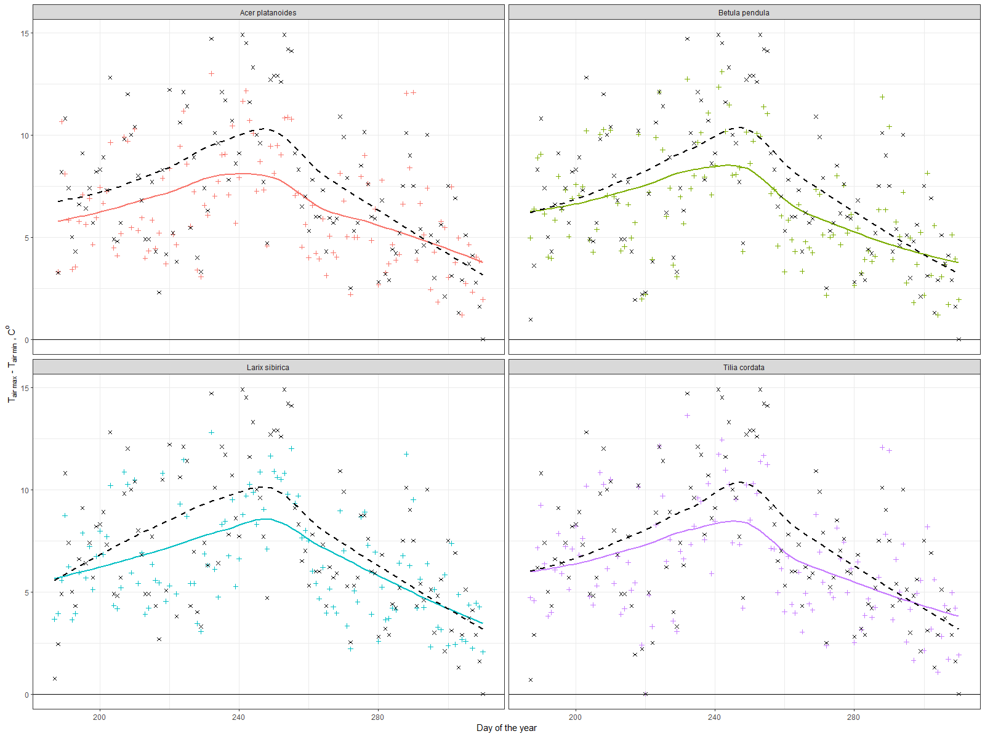

Figure 5. Daily maximum amplitude differences between reference station TT-R (black line) and TT+

These findings correspond well to Chen et al. (2019), who explained observed seasonal dynamics of temperature reduction rates by differences in transpiration and to Rahman et al. (2020), who also found that within the canopy radius of 4.5m of Acer platanoides or Tilia cordata trees, daytime temperature decreased up to 3.5 ℃ during August in comparison of the unshaded surrounding area. Our results go in a line with the meta-analysis study, which showed relations between individual tree characteristics and daily/seasonal temperature reduction dynamics in different climate and urban conditions (Rahman et al., 2020). Temperature reduction by urban green infrastructure on about 0.5-2.5℃ degrees was also shown in several papers, which used computational modeling (Buccolieri et al., 2019; Morakinyo et al., 2020) and satellite based data such as land surface temperature (Kremer et al., 2016; Tonyaloğlu, 2020).

* 1. Run-off mitigation and energy consumption by trees via transpiration

In figure 6 we show an ensemble of transpiration daily patterns for the investigated individuals which show the typical diurnal behavior modulated by changing environmental parameters. Basically the sap flux during night for all individuals was negligible, while during the day it raise up to 3 lh-1 for birch trees and even 5 for several limes and maples trees in July.

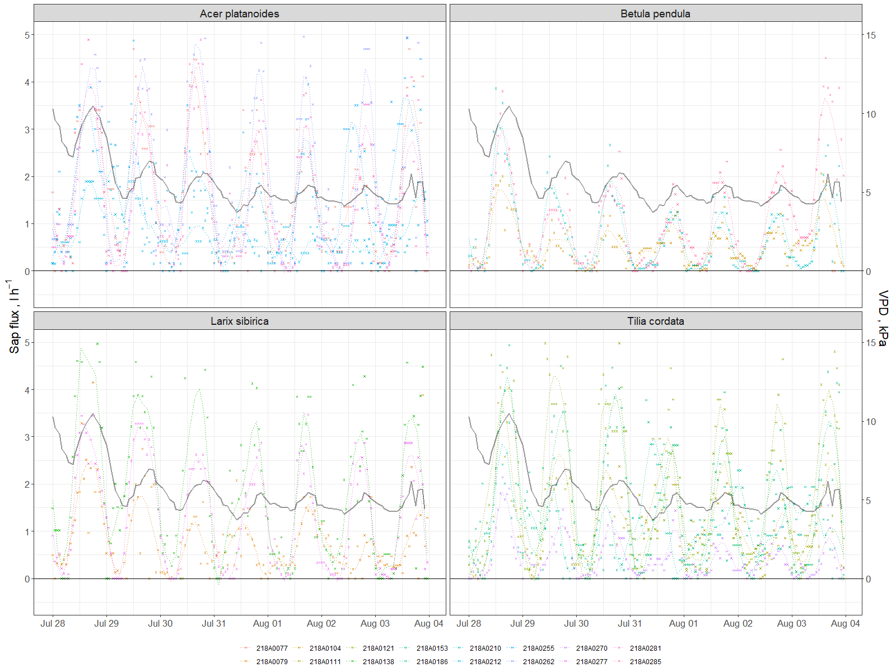

Figure 6 Sap flux and VPD (black line) dynamics for several days during investigated period.

For the purpose of the current study we report the cumulated transpired amount of water in relation to seasonal rainfall. The units are expressed in mm of water where for each of the tree, transpiration rates have been converted in mm by using the tree canopy area. The main purpose is to show, from ecosystem services perspective, the possibility of a tree to serve as a sewage system to mitigate flooding from rains. Our results show that maple and lime trees reduced 130 ±50 mm (± standard error) of water through the investigated period, larch trees 90±50 mm, while young birch –300±50 mm (annex 3, fig. 7). In general, this cumulative process was mostly linear with some differences in rates that can be associated with different VTA scores and standing conditions. On the other hand, there were no significant response to the heavy rains.

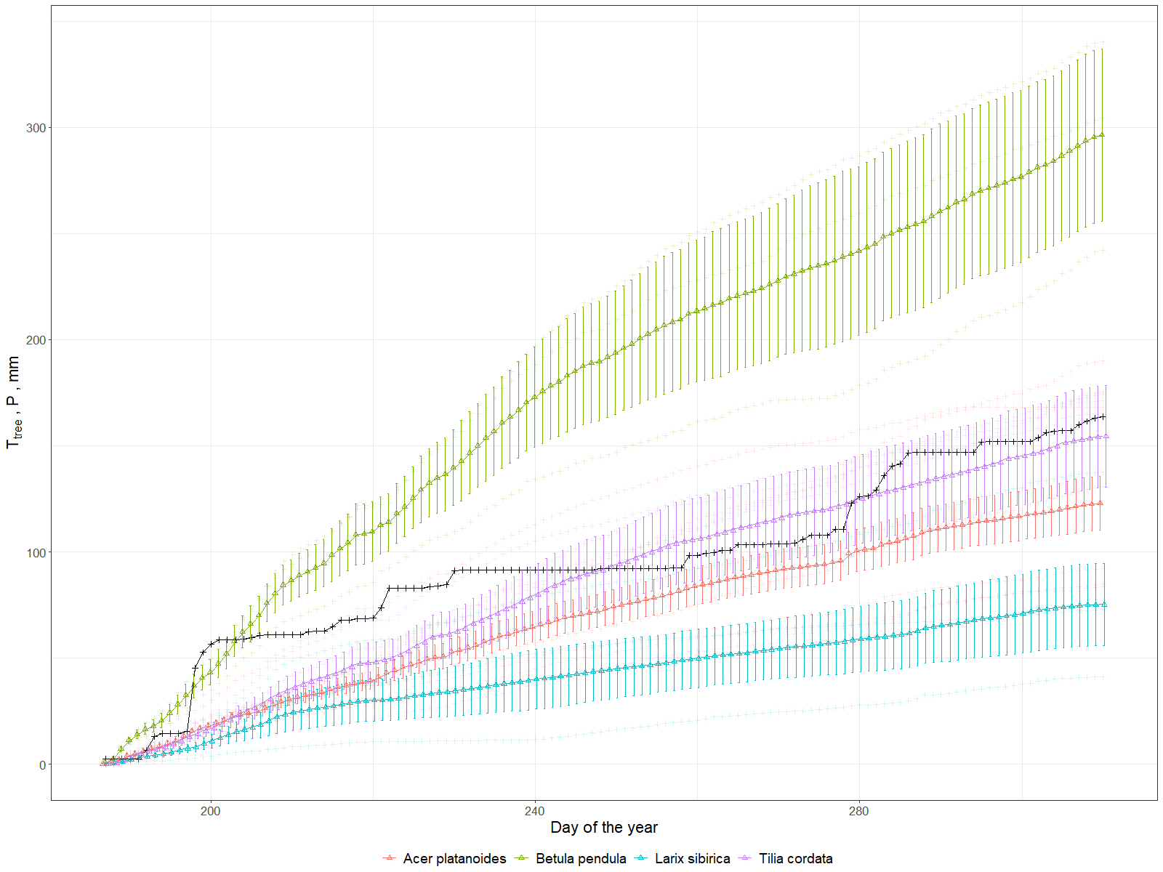

Figure 7.Average transpiration per species compared to precipitation (black line), whiskers denote standard error

Using the energy balance equation (3) it was possible to estimate the amount of absorbed radiation that is subtracted from the environment due to transpiration. Diurnal graph shows the increase of the absorbed latent heat (L) during daytime when transpiration starts following the sun rise (fig.8). Daily range of adsorbed energy during July and August was 0.5-2.2 kWh for maple, larch and lime trees, while for birch it was a bit lower (0.2-1.5 kWh). Already in September there was a decrease in absolute numbers below 1.2 kWh for all species, but the range for maple was 0.6-1.2 kWh, and for birch again on a level of 0.1-0.6 kWh. On contrary during October and November the lowest values were shown by maple trees (with a range 0.1-0.2) while for all other species it was 0.2-0.8 kWh. In average during the investigated period we got 2471.2±266 kWh (± standard error) of energy accumulated by maples, 1379.4±436.7 kWh – by birch, 2140±676.8 kWh – by larch and 2221.7 ±385.4 kWh – by lime trees. Also, the differences between individuals are noticeable (fig.9)

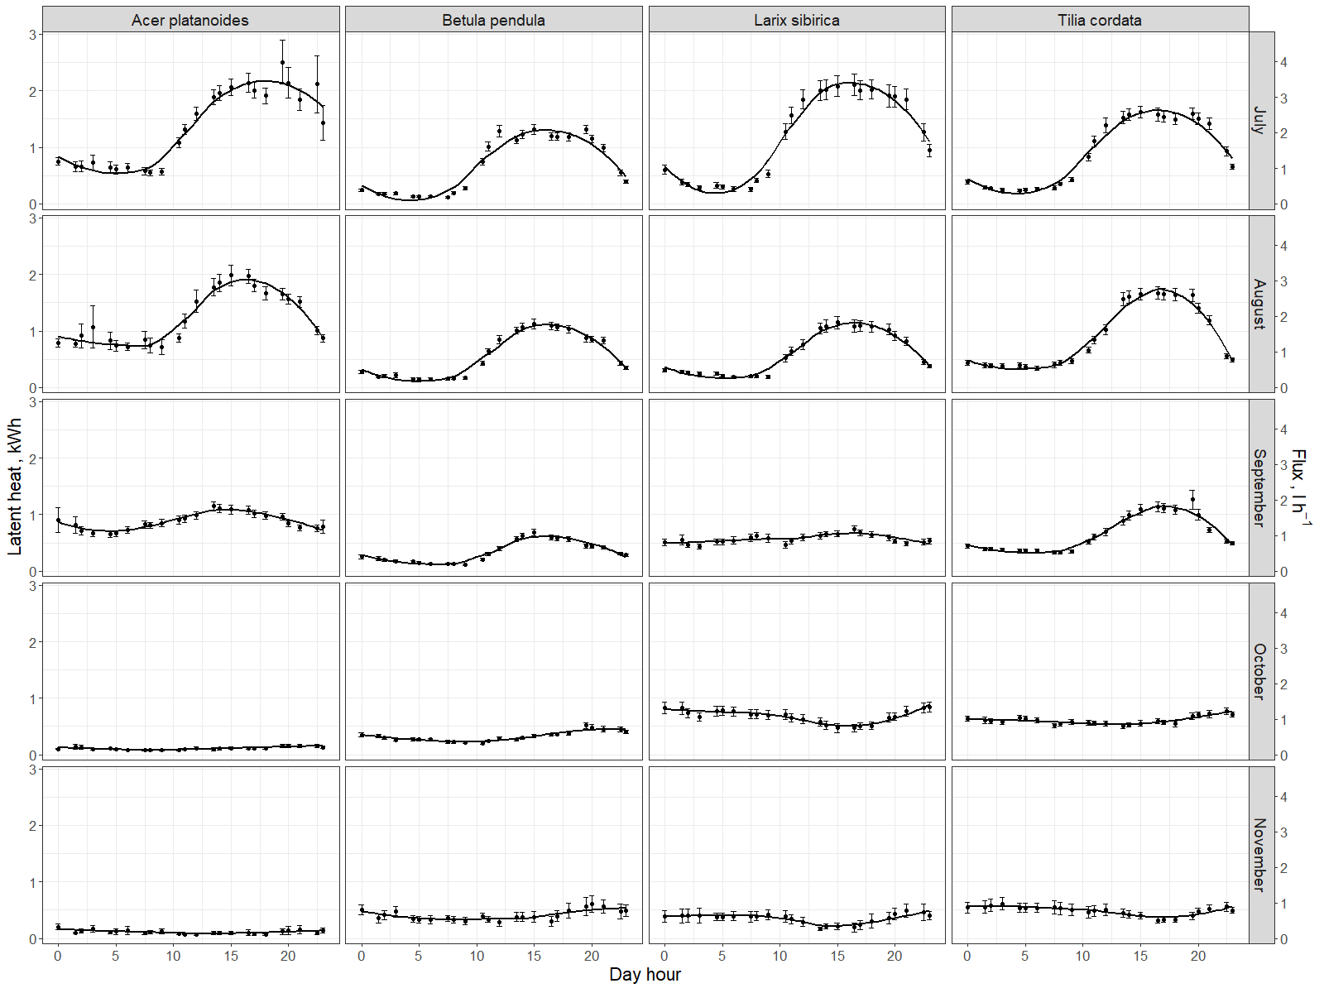

Figure 8. Diurnal dynamics of Latent heat (L) and sap flow for different species averaged per month

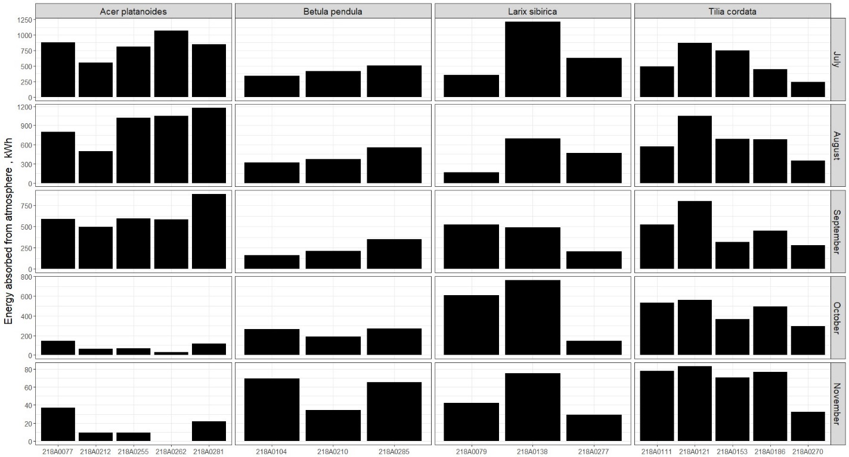

Figure 9. Energy removed from atmosphere monthly by each investigated tree

Trees energy latent het fluxes varied between species, individual trees and seasons. Authors reckon that that main variability between individual trees was due to difference in size of the canopy and position of the tree in the plot. Nevertheless, there are not much publication about energy balance of boreal urban trees, however we got comparable number for lime in summer months (Moser et al., 2015). According to our data we can say that up to 80% of water coming with the rains can be removed thanks to tree transpiration. For investigated period the ability of individual trees to transpire precipitated water volume around them positively correlates with size and density of those species canopies, that correlates with similar works (Moser et al., 2015; Riikonen et al., 2016). Taking into account density of the stand it can be assumed that for investigated plot annual rainfall and transpiration could be close for years without extreme rainfall ranges, what was shown for boreal urban trees of other cities (Marchionni et al., 2019; Zölch et al., 2017). Such information obtained real time could considerably contribute to cities stormwater management (Livesley et al., 2016; Scharenbroch et al., 2016; Xiao and McPherson, 2016). It is widely discussed that rain interception for run-off mitigation consists from several important parts, e.g. leaf buffering during heavy rains (Prasad Ghimire et al., 2017; Syrbe et al., 2018; Valente et al., 2020), which is also based on leaf area index.

* 1. LAI as a proxy for several ES

The LAI dynamics is very important since it is a good proxy for several types of Ecosystem Services, such as wind velocity and noise reduction, pollution regulation and erosion protection via leaves as a buffer. From our radiation sensor we can calculate the overall plant area index (PAI) that is just a sum of leaves and wood (bark) light interception effect. Thus, after comparing periods with and without leaves we can derive both leaf and wood area index. These periods are clearly visible in figure 10 where we can easily distinguish the time of defoliation which lasted one week in first days of October. It is interesting to note that for an individual tree this process can take in reality one-two days. Only due to our perception of green areas as a whole, often derived by airborne images, we think this process has a slower dynamics. As a result, average LAI of all trees (annex 3) was on 3.77 with less range in Betula (3.5-3.7) and higher variation for Acer (3.2-4.3) and Tillia (3.4-4.3). For Larix range was 3.6-3.9, despite our expectations for higher values, which difference can be explained by the higher insertion of the crown.

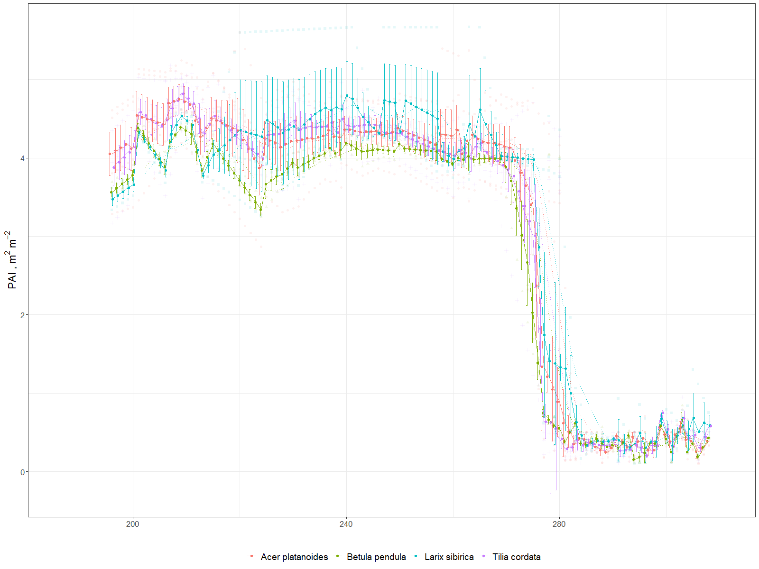

Figure 10. PAI dynamics averaged per species during investigated period (July-November, 2019), whiskers denote standard error.

Despite the well described dynamics, Leaf Area Index, estimated by the spectrometer was influenced by the angle of view of the spectrometer, which is ± 10° and positioned in the North side of the trunk, thus recording only one section of the crown. For a better absolute determination it is necessary to compare the sensor with more precise technics (e.g. camera with fish-eye lens or other LAI meters) which are essential for calibration and validation (Bremer et al., 2017; Yan et al., 2019). But the absolute values (3-4) are comparable to most of the papers (Neinavaz et al., 2016; Taheriazad et al., 2019; Yan et al., 2019) in similar species. While the strong correlation between LAI and DBH and also between LAI and tree height was shown previously for Canadian and Bavarian boreal forests (Taheriazad et al., 2019; Zhu et al., 2018) our results did not allow us to confirm this, that is possible explained with small amount of trees in consideration and urban conditions (Klingberg et al., 2017). However the real time dynamics of LAI and WAI is the advantage of our device which is important for plant physiological processes and models based on it (R. Wang et al., 2019).

* 1. Particulate adsorption

Particulate adsorption is influenced by two main parameters – PAI and particulate concentration in air, according to the model described in Methods. The absorption dynamic during investigated period mostly reflected the changes in the air pollution level by particulate concentration, which shows peaks in the end of July and beginning of August, then in September and late November. While the reasons of this pollution dynamics were not in our focus, we can only say that the average absorption rates differ among investigated trees, due to their canopy area firstly. The lowest adsorption rates were shown by birch trees on an average level of 9.3 g per day, the highest were maple and larch trees 51.2 and 51.4 g per day respectively, while lime were in a middle with 25.5 g per day per tree (fig. 12). The highest adsorption peaks (in terms of maximum deposition velocity) were up to 1200 g (Larix) during several days with the high concentrations in the air. This parameter shows drastic variation across time.

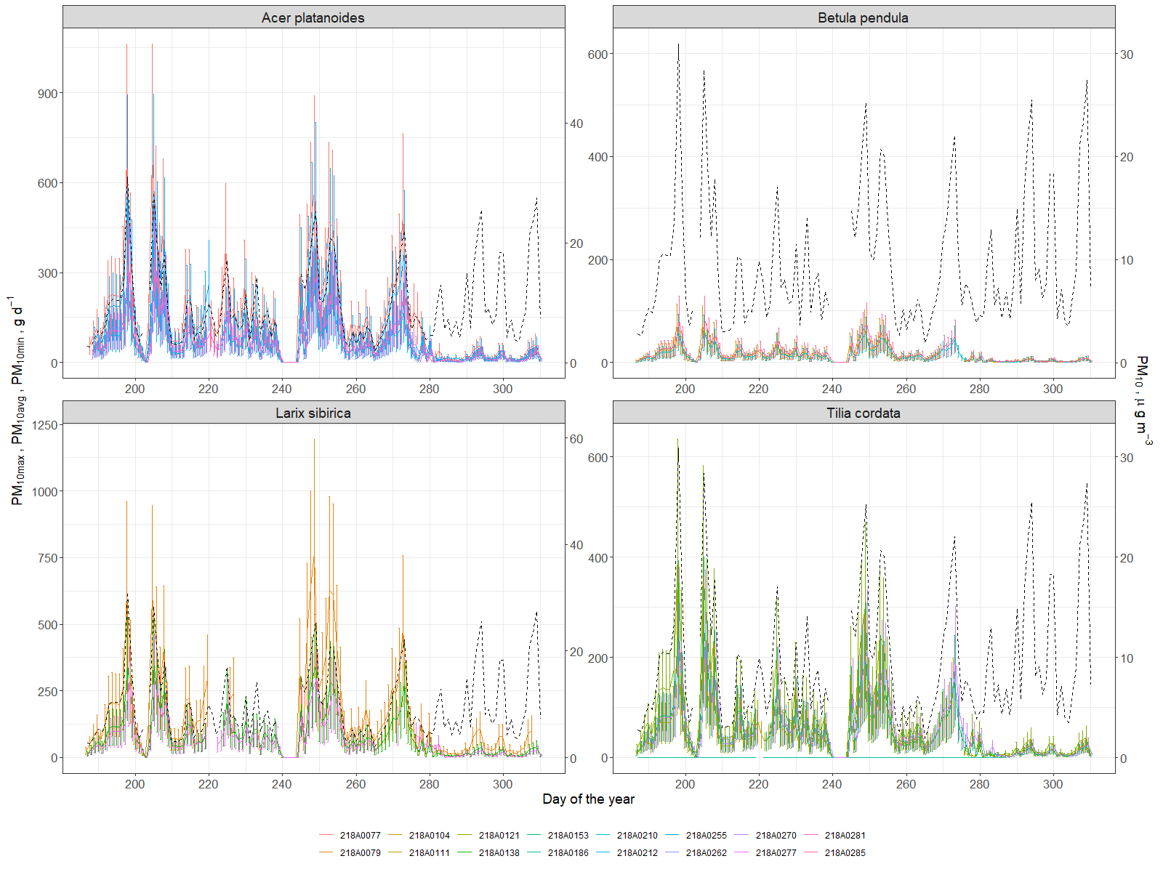

Figure 11. Dynamics of atmospheric particulate matter with diameter less than 10 micrometers (PM10) averaged daily concentration in air (dashed line) and amount of PM10 absorbed by investigated trees daily (line shows average value, while whiskers denote min and max)

The cumulative particulate mass absorption over the season was 7.7 ±1.5 kg for Acer (± standard error), 7.7±2.1 kg for Larix, 3.8±0.2 kg for Tillia, and 1.4±0.1 kg for Betula (annex 3). Sæbø et al. (2012) showed that Betula improves air quality by particulate adsorption much better than Acer and Tillia, that can be explained (in our case) just by the size of a tree. It is well known that healthy large trees remove about 60 times more pollution annually than healthy small trees (Nowak et al., 2006). And leaf wax or leaf hair density and topography also influenced much (Muhammad et al., 2019; Sæbø et al., 2012). In our case we could not include leaf morphology or topography since our estimation was based on LAI. However the total adsorption by tree seems comparable with several works with an average 0.5-5 g m-2 rates of adsorption in different cities (Bottalico et al., 2016; Nowak et al., 2018; Selmi et al., 2016), which resulted in 10-200g daily per tree. Thus, our results from Moscow center with high traffic look comparable.

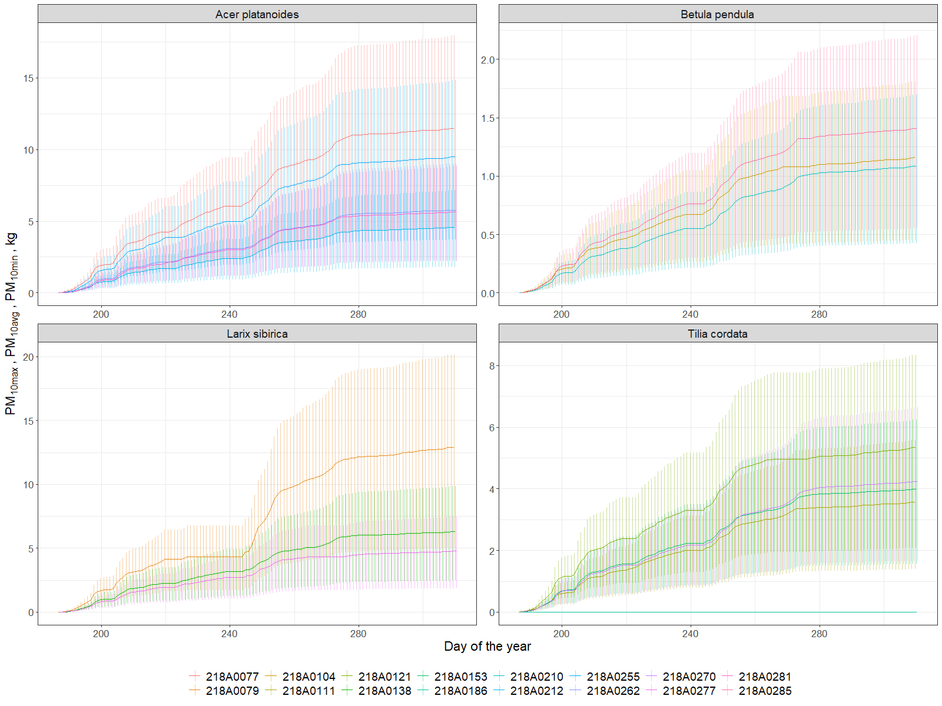

Figure 12. Cumulative particulate adsorption (minimum, average and maximum) by tree leaves per investigated period (July-November, 2019).

**Conclusions**

According to our findings we can summarize our results on ecosystem services estimation with an individual tree average of 8.61± 1.25 kg of Carbon stored (± standard error), 161± 21 mm of water transpired, 2167± 181 kWh spent for microclimate regulation and 5309±808 g of PM10 adsorbed per investigated period (July-November, 2019).

There are several approaches to provide ecosystem services information for the green infrastructure in urban areas. However, most of the inventory types approaches, even when based on high resolution imaging, are limited by the temporal resolution which sometime is important for detecting an early onset of ES decline. Our results show that an IoT tree level network, using individual tree physiology sensing devices, such as TreeTalker, or other similar devices, can be used in principle for monitoring urban green infrastructure ecosystem services in real time. Furthermore, for some of the ES indicator, such as water and cooling effects, they are most often based on models with indirect derived parameters. Having real time and individual tree data can improve our predictions and urban green infrastructure planning. There are several advantages for increasing the granularity of ES monitoring, since individual trees can be managed with a greater accuracy. The cost of monitoring is therefore critical for IoT expansion in green infrastructure monitoring. In recent years technological development and low cost microprocessors, traditionally used in automation and industry processes (Industry4.0), are creating new opportunities for their expansion in environmental monitoring, that we could define as a Nature4.0 transformation (Valentini et al., 2019). An average cost of 200-300 Euro per point of measurements (tree), including the LoRa gateway, have been estimated in our experiment.

However, there are limitations and improvements to be considered in future work. First of all the power consumption of the TreeTalker devices, used in the current work, is still a big limitation. Batteries need to be replaced every 1-1.5 months which require still quite investment of labor work. New batteries are being developed with much larger capacity that in principle could extend the battery life duration. In terms of improvement a new IR sensor for remote sensing of canopy temperature could be very useful for improving the energy balance estimation and cooling effects. In particular, the installation of an anemometer will provide additional data on wind speed in the canopy, which influence much several ecosystem services. In addition simple PM2.5-10 optical devices can be included in the processor platform to get useful data on air quality using trees as monitor stations. In principle, but further studies need to be conducted, a noise sensor and microphone could also be included with the aim to provide useful information on the noise pollution and “soundscape” quality generated by trees in parks (Doser et al., 2020; Mydlarz et al., 2019) and also to evaluate associated biodiversity with the help of recorded bird songs (Farina et al., 2014; Margaritis et al., 2018). Nevertheless, the technical development of sensors along with people engagement to citizen science will be inevitable (Bauer et al., 2019; Nitoslawski et al., 2019; Schröter et al., 2017), thus it will be important to adapt them to the task of monitoring those parameters that are important for urban planning decisions (Cortinovis and Geneletti, 2019).

Among the indicators presented in the article, perhaps not all of them can be used for practical purposes directly. Air temperature and humidity under the canopy of city trees can be presented “as is” for people, as well as wind speed for example. However, in order to monitor the quality of the urban environment associated with green infrastructure, it is probably worth developing specific scales of air quality, microclimate comfort and noise pollution levels – in this form it makes more clear information for citizens. On the other hand, for spatial planning tasks, it will be useful to create a urban tree database on annual or seasonal indicators of ecosystem services provided by tree species at its specific age, height and condition. This could be very useful for operational management of urban green infrastructures. (Bodnaruk et al., 2017). In addition, it is also necessary to take into account disservices associated with urban trees such as the fall of weakened and diseased trees on cars, infrastructure and buildings, and the allergic reaction of people to tree pollen (Speak et al., 2018; Teixeira et al., 2019). These parameters should also be continuously monitored and reported in real time for rapid response or timely prevention.

**Author Contributions:** Conceptualization, R.V. and V.M.; methodology, X.X.; software, A.Y. and L.B.; validation, G.S., L.B. and Z.Z.; formal analysis, X.X.; investigation, G.S., L.B, O.F., I.S; resources, X.X., Y.Y. and Z.Z.; data curation, A.Y.; writing—original draft preparation, V.M.; writing—review and editing, R.V. and S.C.; visualization, A.Y.; supervision, R.V.; project administration, V.V.; funding acquisition, Y.Y. All authors have read and agreed to the published version of the manuscript.

**Funding:** Monitoring and modeling ecosystem services of urban trees was supported by Russian Scientific Foundation Project # 19-77-300-12. Data processing and analysis was supported by “RUDN University program 5‐100.”

**Acknowledgments:** In this section you can acknowledge any support given which is not covered by the author contribution or funding sections. This may include administrative and technical support, or donations in kind (e.g., materials used for experiments).

**Conflicts of Interest:** The authors declare no conflict of interest.

**7. Literature**

Aalders, I., Stanik, N., 2019. Spatial units and scales for cultural ecosystem services: a comparison illustrated by cultural heritage and entertainment services in Scotland. Landsc. Ecol. 34, 1635–1651. https://doi.org/10.1007/s10980-019-00827-6

Albino, V., Berardi, U., Dangelico, R.M., 2015. Smart Cities: Definitions, Dimensions, Performance, and Initiatives. J. Urban Technol. 22, 3–21. https://doi.org/10.1080/10630732.2014.942092

Alonzo, M., Bookhagen, B., Roberts, D.A., 2014. Urban tree species mapping using hyperspectral and lidar data fusion. Remote Sens. Environ. 148, 70–83. https://doi.org/10.1016/j.rse.2014.03.018

Andersson, E., Barthel, S., Borgström, S., Colding, J., Elmqvist, T., Folke, C., Gren, Å., 2014. Reconnecting Cities to the Biosphere: Stewardship of Green Infrastructure and Urban Ecosystem Services. AMBIO 43, 445–453. https://doi.org/10.1007/s13280-014-0506-y

Andersson-Sköld, Y., Klingberg, J., Gunnarsson, B., Cullinane, K., Gustafsson, I., Hedblom, M., Knez, I., Lindberg, F., Ode Sang, Å., Pleijel, H., Thorsson, P., Thorsson, S., 2018. A framework for assessing urban greenery’s effects and valuing its ecosystem services. J. Environ. Manage. 205, 274–285. https://doi.org/10.1016/j.jenvman.2017.09.071

Andrea, F., Bini, C., Amaducci, S., 2018. Soil and ecosystem services: Current knowledge and evidences from Italian case studies. Appl. Soil Ecol. 123, 693–698. https://doi.org/10.1016/j.apsoil.2017.06.031

Augustaitis, A., Augustaitienė, I., Baugarten, M., Bičenkienė, S., Girgždienė, R., Kulbokas, G., Linkevičius, E., Marozas, V., Mikalajūnas, M., Mordas, G., Mozgeris, G., Petrauskas, E., Pivoras, A., Šidlauskas, G., Ulevičius, V., Vitas, A., Matyssek, R., 2018. Tree-ring formation as an indicator of forest capacity to adapt to the main threats of environmental changes in Lithuania. Sci. Total Environ. 615, 1247–1261. https://doi.org/10.1016/j.scitotenv.2017.09.169

Augustaitis, A., Augustaitiene, I., Mozgeris, G., Juknys, R., Vitas, A., Jasinevičiene, D., 2015. Growth patterns of Scots pine (Pinus sylvestris L.) under the current regional pollution load in Lithuania. IForest - Biogeosciences For. 8, 509–516. https://doi.org/10.3832/ifor1267-007

Bauer, J., Jarmer, T., Schittenhelm, S., Siegmann, B., Aschenbruck, N., 2019. Processing and filtering of leaf area index time series assessed by in-situ wireless sensor networks. Comput. Electron. Agric. 165, 104867. https://doi.org/10.1016/j.compag.2019.104867

Bettencourt, L.M.A., Lobo, J., Helbing, D., Kuhnert, C., West, G.B., 2007. Growth, innovation, scaling, and the pace of life in cities. Proc. Natl. Acad. Sci. 104, 7301–7306. https://doi.org/10.1073/pnas.0610172104

Blanusa, T., Garratt, M., Cathcart-James, M., Hunt, L., Cameron, R.W.F., 2019. Urban hedges: A review of plant species and cultivars for ecosystem service delivery in north-west Europe. Urban For. Urban Green. 44, 126391. https://doi.org/10.1016/j.ufug.2019.126391

Bodnaruk, E.W., Kroll, C.N., Yang, Y., Hirabayashi, S., Nowak, D.J., Endreny, T.A., 2017. Where to plant urban trees? A spatially explicit methodology to explore ecosystem service tradeoffs. Landsc. Urban Plan. 157, 457–467. https://doi.org/10.1016/j.landurbplan.2016.08.016

Bolund, P., Hunhammar, S., 1999. Ecosystem services in urban areas. Ecol. Econ. 29, 293–301. https://doi.org/10.1016/S0921-8009(99)00013-0

Bottalico, F., Chirici, G., Giannetti, F., De Marco, A., Nocentini, S., Paoletti, E., Salbitano, F., Sanesi, G., Serenelli, C., Travaglini, D., 2016. Air Pollution Removal by Green Infrastructures and Urban Forests in the City of Florence. Agric. Agric. Sci. Procedia 8, 243–251. https://doi.org/10.1016/j.aaspro.2016.02.099

Bremer, M., Wichmann, V., Rutzinger, M., 2017. Calibration and Validation of a Detailed Architectural Canopy Model Reconstruction for the Simulation of Synthetic Hemispherical Images and Airborne LiDAR Data. Remote Sens. 9, 220. https://doi.org/10.3390/rs9030220

Buccolieri, R., Santiago, J.-L., Rivas, E., Sáanchez, B., 2019. Reprint of: Review on urban tree modelling in CFD simulations: Aerodynamic, deposition and thermal effects. Urban For. Urban Green. 37, 56–64. https://doi.org/10.1016/j.ufug.2018.07.004

Burkhard, B., Maes, J., Potschin-Young, M., Santos-Martín, F., Geneletti, D., Stoev, P., Kopperoinen, L., Adamescu, C., Adem Esmail, B., Arany, I., Arnell, A., Balzan, M., Barton, D.N., van Beukering, P., Bicking, S., Borges, P., Borisova, B., Braat, L., M Brander, L., Bratanova-Doncheva, S., Broekx, S., Brown, C., Cazacu, C., Crossman, N., Czúcz, B., Daněk, J., Groot, R. de, Depellegrin, D., Dimopoulos, P., Elvinger, N., Erhard, M., Fagerholm, N., Frélichová, J., Grêt-Regamey, A., Grudova, M., Haines-Young, R., Inghe, O., Kallay, T., Kirin, T., Klug, H., Kokkoris, I., Konovska, I., Kruse, M., Kuzmova, I., Lange, M., Liekens, I., Lotan, A., Lowicki, D., Luque, S., Marta-Pedroso, C., Mizgajski, A., Mononen, L., Mulder, S., Müller, F., Nedkov, S., Nikolova, M., Östergård, H., Penev, L., Pereira, P., Pitkänen, K., Plieninger, T., Rabe, S.-E., Reichel, S., Roche, P., Rusch, G., Ruskule, A., Sapundzhieva, A., Sepp, K., Sieber, I., Šmid Hribar, M., Stašová, S., Steinhoff-Knopp, B., Stępniewska, M., Teller, A., Vackar, D., van Weelden, M., Veidemane, K., Vejre, H., Vihervaara, P., Viinikka, A., Villoslada, M., Weibel, B., Zulian, G., 2018. Mapping and assessing ecosystem services in the EU - Lessons learned from the ESMERALDA approach of integration. One Ecosyst. 3. https://doi.org/10.3897/oneeco.3.e29153

Chen, X., Zhao, P., Hu, Y., Ouyang, L., Zhu, L., Ni, G., 2019. Canopy transpiration and its cooling effect of three urban tree species in a subtropical city- Guangzhou, China. Urban For. Urban Green. 43, 126368. https://doi.org/10.1016/j.ufug.2019.126368

Cortinovis, C., Geneletti, D., 2019. A framework to explore the effects of urban planning decisions on regulating ecosystem services in cities. Ecosyst. Serv. 38, 100946. https://doi.org/10.1016/j.ecoser.2019.100946

Czúcz, B., Arany, I., Potschin-Young, M., Bereczki, K., Kertész, M., Kiss, M., Aszalós, R., Haines-Young, R., 2018. Where concepts meet the real world: A systematic review of ecosystem service indicators and their classification using CICES. Ecosyst. Serv. 29, 145–157. https://doi.org/10.1016/j.ecoser.2017.11.018

Do, F.C., Puangjumpa, N., Rocheteau, A., Duthoit, M., Nhean, S., Isarangkool Na Ayutthaya, S., 2018. Towards reduced heating duration in the transient thermal dissipation system of sap flow measurements. Acta Hortic. 149–154. https://doi.org/10.17660/ActaHortic.2018.1222.31 4)

Do, F. C., Isarangkool Na Ayutthaya, S., & Rocheteau, A. (2011). Transient thermal dissipation method for xylem sap flow measurement: implementation with a single probe. Tree Physiology, 31(4), 369–380. https://doi.org/10.1093/treephys/tpr020

Doser, J.W., Finley, A.O., Kasten, E.P., Gage, S.H., 2020. Assessing soundscape disturbance through hierarchical models and acoustic indices: A case study on a shelterwood logged northern Michigan forest. Ecol. Indic. 113, 106244. https://doi.org/10.1016/j.ecolind.2020.106244

Drobnik, T., Greiner, L., Keller, A., Grêt-Regamey, A., 2018. Soil quality indicators – From soil functions to ecosystem services. Ecol. Indic. 94, 151–169. https://doi.org/10.1016/j.ecolind.2018.06.052

Dye, C., 2008. Health and Urban Living. Science 319, 766. https://doi.org/10.1126/science.1150198

Elliott, S., 2016. The potential for automating assisted natural regeneration of tropical forest ecosystems. Biotropica 48, 825–833. https://doi.org/10.1111/btp.12387

Farina, A., James, P., Bobryk, C., Pieretti, N., Lattanzi, E., McWilliam, J., 2014. Low cost (audio) recording (LCR) for advancing soundscape ecology towards the conservation of sonic complexity and biodiversity in natural and urban landscapes. Urban Ecosyst. 17, 923–944. https://doi.org/10.1007/s11252-014-0365-0

Frumkin, H., 2003. Healthy Places: Exploring the Evidence. Am. J. Public Health 93, 1451–1456. https://doi.org/10.2105/AJPH.93.9.1451

Gómez-Baggethun, E., Barton, D.N., 2013. Classifying and valuing ecosystem services for urban planning. Ecol. Econ. 86, 235–245. https://doi.org/10.1016/j.ecolecon.2012.08.019

Granier A (1985) A new method of sap flow measurement in tree stems. Ann For Sci 42:193–200

Gratani, L., Varone, L., 2006. Carbon sequestration by Quercus ilex L. and Quercus pubescens Willd. and their contribution to decreasing air temperature in Rome. Urban Ecosyst. 9, 27–37. https://doi.org/10.1007/s11252-006-5527-2

Grimm, N.B., Faeth, S.H., Golubiewski, N.E., Redman, C.L., Wu, J., Bai, X., Briggs, J.M., 2008. Global Change and the Ecology of Cities. Science 319, 756. https://doi.org/10.1126/science.1150195

Guo, Z., Zhang, L., Li, Y., 2010. Increased Dependence of Humans on Ecosystem Services and Biodiversity. PLoS ONE 5, e13113. https://doi.org/10.1371/journal.pone.0013113

Haaren, C. von, Lovett, A.A., Albert, C., 2019. Landscape planning with ecosystem services: theories and methods for application in Europe.

Haase, D., Larondelle, N., Andersson, E., Artmann, M., Borgström, S., Breuste, J., Gomez-Baggethun, E., Gren, Å., Hamstead, Z., Hansen, R., Kabisch, N., Kremer, P., Langemeyer, J., Rall, E.L., McPhearson, T., Pauleit, S., Qureshi, S., Schwarz, N., Voigt, A., Wurster, D., Elmqvist, T., 2014. A Quantitative Review of Urban Ecosystem Service Assessments: Concepts, Models, and Implementation. AMBIO 43, 413–433. https://doi.org/10.1007/s13280-014-0504-0

Hefny Salim, M., Heinke Schlünzen, K., Grawe, D., 2015. Including trees in the numerical simulations of the wind flow in urban areas: Should we care? J. Wind Eng. Ind. Aerodyn. 144, 84–95. https://doi.org/10.1016/j.jweia.2015.05.004

Hirabayashi, S., Kroll, C.N., Nowak, D.J., 2012. i-Tree Eco Dry Deposition Model Descriptions 36.

Kang, G., Kim, J.-J., Choi, W., 2020. Computational fluid dynamics simulation of tree effects on pedestrian wind comfort in an urban area. Sustain. Cities Soc. 56, 102086. https://doi.org/10.1016/j.scs.2020.102086

Kitchin, R., 2014. The real-time city? Big data and smart urbanism. GeoJournal 79, 1–14. https://doi.org/10.1007/s10708-013-9516-8

Klingberg, J., Konarska, J., Lindberg, F., Johansson, L., Thorsson, S., 2017. Mapping leaf area of urban greenery using aerial LiDAR and ground-based measurements in Gothenburg, Sweden. Urban For. Urban Green. 26, 31–40. https://doi.org/10.1016/j.ufug.2017.05.011

Krausmann, F., Lauk, C., Haas, W., Wiedenhofer, D., 2018. From resource extraction to outflows of wastes and emissions: The socioeconomic metabolism of the global economy, 1900–2015. Glob. Environ. Change 52, 131–140. https://doi.org/10.1016/j.gloenvcha.2018.07.003

Krayenhoff, E.S., Jiang, T., Christen, A., Martilli, A., Oke, T.R., Bailey, B.N., Nazarian, N., Voogt, J.A., Giometto, M.G., Stastny, A., Crawford, B.R., 2020. A multi-layer urban canopy meteorological model with trees (BEP-Tree): Street tree impacts on pedestrian-level climate. Urban Clim. 32, 100590. https://doi.org/10.1016/j.uclim.2020.100590

Kremer, P., Hamstead, Z.A., McPhearson, T., 2016. The value of urban ecosystem services in New York City: A spatially explicit multicriteria analysis of landscape scale valuation scenarios. Environ. Sci. Policy 62, 57–68. https://doi.org/10.1016/j.envsci.2016.04.012

La Rosa, D., Spyra, M., Inostroza, L., 2016. Indicators of Cultural Ecosystem Services for urban planning: A review. Ecol. Indic. 61, 74–89. https://doi.org/10.1016/j.ecolind.2015.04.028

Lederbogen, F., Kirsch, P., Haddad, L., Streit, F., Tost, H., Schuch, P., Wüst, S., Pruessner, J.C., Rietschel, M., Deuschle, M., Meyer-Lindenberg, A., 2011. City living and urban upbringing affect neural social stress processing in humans. Nature 474, 498–501. https://doi.org/10.1038/nature10190

Lee, K.H., Ehsani, R., Castle, W.S., 2010. A laser scanning system for estimating wind velocity reduction through tree windbreaks. Comput. Electron. Agric. 73, 1–6. https://doi.org/10.1016/j.compag.2010.03.007

Lilly, P.J., Jenkins, J.C., Carroll, M.J., 2015. Management alters C allocation in turfgrass lawns. Landsc. Urban Plan. 134, 119–126. https://doi.org/10.1016/j.landurbplan.2014.10.011

Lin, J., Kroll, C.N., Nowak, D.J., Greenfield, E.J., 2019. A review of urban forest modeling: Implications for management and future research. Urban For. Urban Green. 43, 126366. https://doi.org/10.1016/j.ufug.2019.126366

Lindén, L., Riikonen, A., Setälä, H., Yli-Pelkonen, V., 2020. Quantifying carbon stocks in urban parks under cold climate conditions. Urban For. Urban Green. 49, 126633. https://doi.org/10.1016/j.ufug.2020.126633

Livesley, S.J., McPherson, E.G., Calfapietra, C., 2016. The Urban Forest and Ecosystem Services: Impacts on Urban Water, Heat, and Pollution Cycles at the Tree, Street, and City Scale. J. Environ. Qual. 45, 119–124. https://doi.org/10.2134/jeq2015.11.0567

Lovell, S.T., Taylor, J.R., 2013. Supplying urban ecosystem services through multifunctional green infrastructure in the United States. Landsc. Ecol. 28, 1447–1463. https://doi.org/10.1007/s10980-013-9912-y

Luederitz, C., Brink, E., Gralla, F., Hermelingmeier, V., Meyer, M., Niven, L., Panzer, L., Partelow, S., Rau, A.-L., Sasaki, R., Abson, D.J., Lang, D.J., Wamsler, C., von Wehrden, H., 2015. A review of urban ecosystem services: six key challenges for future research. Ecosyst. Serv. 14, 98–112. https://doi.org/10.1016/j.ecoser.2015.05.001

Marando, F., Salvatori, E., Sebastiani, A., Fusaro, L., Manes, F., 2019. Regulating Ecosystem Services and Green Infrastructure: assessment of Urban Heat Island effect mitigation in the municipality of Rome, Italy. Ecol. Model. 392, 92–102. https://doi.org/10.1016/j.ecolmodel.2018.11.011

Marchionni, V., Guyot, A., Tapper, N., Walker, J.P., Daly, E., 2019. Water balance and tree water use dynamics in remnant urban reserves. J. Hydrol. 575, 343–353. https://doi.org/10.1016/j.jhydrol.2019.05.022

Margaritis, E., Kang, J., Filipan, K., Botteldooren, D., 2018. The influence of vegetation and surrounding traffic noise parameters on the sound environment of urban parks. Appl. Geogr. 94, 199–212. https://doi.org/10.1016/j.apgeog.2018.02.017

Mascarenhas, A., Ramos, T.B., Haase, D., Santos, R., 2016. Participatory selection of ecosystem services for spatial planning: Insights from the Lisbon Metropolitan Area, Portugal. Ecosyst. Serv. 18, 87–99. https://doi.org/10.1016/j.ecoser.2016.02.011

Mesas-Carrascosa, F.J., Verdú Santano, D., Meroño, J.E., Sánchez de la Orden, M., García-Ferrer, A., 2015. Open source hardware to monitor environmental parameters in precision agriculture. Biosyst. Eng. 137, 73–83. https://doi.org/10.1016/j.biosystemseng.2015.07.005

Mexia, T., Vieira, J., Príncipe, A., Anjos, A., Silva, P., Lopes, N., Freitas, C., Santos-Reis, M., Correia, O., Branquinho, C., Pinho, P., 2018. Ecosystem services: Urban parks under a magnifying glass. Environ. Res. 160, 469–478. https://doi.org/10.1016/j.envres.2017.10.023

Moghbel, M., Erfanian Salim, R., 2017. Environmental benefits of green roofs on microclimate of Tehran with specific focus on air temperature, humidity and CO 2 content. Urban Clim. 20, 46–58. https://doi.org/10.1016/j.uclim.2017.02.012

Morakinyo, T.E., Ouyang, W., Lau, K.K.-L., Ren, C., Ng, E., 2020. Right tree, right place (urban canyon): Tree species selection approach for optimum urban heat mitigation - development and evaluation. Sci. Total Environ. 719, 137461. https://doi.org/10.1016/j.scitotenv.2020.137461

Monsi M, Saeki T. 1953. U¨ber den Lichtfaktor in den Pflanzengesellschaften und seine Bedeutung fu¨r die Stoffproduktion. Jpn J Bot. 14:22–52. [Republished in English: Monsi M, Saeki T. 2005. On the factor light in plant communities and its importance for matter production. Ann Bot. 95:549–567.]

Moser, A., Rötzer, T., Pauleit, S., Pretzsch, H., 2015. Structure and ecosystem services of small-leaved lime (Tilia cordata Mill.) and black locust (Robinia pseudoacacia L.) in urban environments. Urban For. Urban Green. 14, 1110–1121. https://doi.org/10.1016/j.ufug.2015.10.005

Moser-Reischl, A., Rahman, M. A., Pauleit, S., Pretzsch, H., & Rötzer, T. (2019). Growth patterns and effects of urban micro-climate on two physiologically contrasting urban tree species. Landscape and urban planning, 183, 88-99.

Muhammad, S., Wuyts, K., Samson, R., 2019. Atmospheric net particle accumulation on 96 plant species with contrasting morphological and anatomical leaf characteristics in a common garden experiment. Atmos. Environ. 202, 328–344. https://doi.org/10.1016/j.atmosenv.2019.01.015

Müller, F., Burkhard, B., 2012. The indicator side of ecosystem services. Ecosyst. Serv. 1, 26–30. https://doi.org/10.1016/j.ecoser.2012.06.001

Mydlarz, C., Sharma, M., Lockerman, Y., Steers, B., Silva, C., Bello, J., 2019. The Life of a New York City Noise Sensor Network. Sensors 19, 1415. https://doi.org/10.3390/s19061415

Neinavaz, E., Skidmore, A.K., Darvishzadeh, R., Groen, T.A., 2016. Retrieval of leaf area index in different plant species using thermal hyperspectral data. ISPRS J. Photogramm. Remote Sens. 119, 390–401. https://doi.org/10.1016/j.isprsjprs.2016.07.001

Neugarten, R.A., Langhammer, P.F., Osipova, E., Bagstad, K.J., Bhagabati, N., Butchart, S.H.M., Dudley, N., Elliott, V., Gerber, L.R., Gutierrez Arrellano, C., Ivanić, K.-Z., Kettunen, M., Mandle, L., Merriman, J.C., Mulligan, M., Peh, K.S.-H., Raudsepp-Hearne, C., Semmens, D.J., Stolton, S., Willcock, S., 2018. Tools for measuring, modelling, and valuing ecosystem services: guidance for Key Biodiversity Areas, natural World Heritage sites, and protected areas, 1st ed. IUCN, International Union for Conservation of Nature. https://doi.org/10.2305/IUCN.CH.2018.PAG.28.en

Nitoslawski, S.A., Galle, N.J., Van Den Bosch, C.K., Steenberg, J.W.N., 2019. Smarter ecosystems for smarter cities? A review of trends, technologies, and turning points for smart urban forestry. Sustain. Cities Soc. 51, 101770. https://doi.org/10.1016/j.scs.2019.101770

Njue, N., Stenfert Kroese, J., Gräf, J., Jacobs, S.R., Weeser, B., Breuer, L., Rufino, M.C., 2019. Citizen science in hydrological monitoring and ecosystem services management: State of the art and future prospects. Sci. Total Environ. 693, 133531. https://doi.org/10.1016/j.scitotenv.2019.07.337

Norton, L., Greene, S., Scholefield, P., Dunbar, M., 2016. The importance of scale in the development of ecosystem service indicators? Ecol. Indic. 61, 130–140. https://doi.org/10.1016/j.ecolind.2015.08.051

Nowak, D.J., Crane, D.E., 2002. Carbon storage and sequestration by urban trees in the USA. Environ. Pollut. 116, 381–389. https://doi.org/10.1016/S0269-7491(01)00214-7

Nowak, D. J., Kuroda, M., & Crane, D. E. 2004. Tree mortality rates and tree population projections in Baltimore, Maryland, USA. Urban forestry & urban greening, 2(3), 139-147.

Nowak, D.J., Crane, D.E., Stevens, J.C., 2006. Air pollution removal by urban trees and shrubs in the United States. Urban For. Urban Green. 4, 115–123. https://doi.org/10.1016/j.ufug.2006.01.007

Nowak, D. J., Greenfield, E. J., Hoehn, R. E., & Lapoint, E. 2013. Carbon storage and sequestration by trees in urban and community areas of the United States. Environmental pollution, 178, 229-236.

Nowak, D.J., Hirabayashi, S., Doyle, M., McGovern, M., Pasher, J., 2018. Air pollution removal by urban forests in Canada and its effect on air quality and human health. Urban For. Urban Green. 29, 40–48. https://doi.org/10.1016/j.ufug.2017.10.019

Opdam, P., Luque, S., Nassauer, J., Verburg, P.H., Wu, J., 2018. How can landscape ecology contribute to sustainability science? Landsc. Ecol. 33, 1–7. https://doi.org/10.1007/s10980-018-0610-7

Pretzsch, H., Biber, Peter, Uhl, Enno, Dahlhausen, Jens, Schütze, Gerhard, Perkins, Diana, Rötzer, Thomas, Caldentey, Juan, Koike, Takayoshi, Con, Tran van, Chavanne, Aurélia, Toit, Ben du, Foster, Keith, Lefer, Barry 2017. Climate change accelerates growth of urban trees in metropolises worldwide. Scientific Reports, 7(1), 1-10.

Pereira, F.L., Gash, J.H.C., David, J.S., Valente, F., 2009. Evaporation of intercepted rainfall from isolated evergreen oak trees: Do the crowns behave as wet bulbs? Agric. For. Meteorol. 149, 667–679. https://doi.org/10.1016/j.agrformet.2008.10.013

Prasad Ghimire, C., Adrian Bruijnzeel, L., Lubczynski, M.W., Ravelona, M., Zwartendijk, B.W., van Meerveld, H.J. (Ilja), 2017. Measurement and modeling of rainfall interception by two differently aged secondary forests in upland eastern Madagascar. J. Hydrol. 545, 212–225. https://doi.org/10.1016/j.jhydrol.2016.10.032

Puzachenko, Y., Sandlersky, R., Sankovski, A., 2013. Methods of Evaluating Thermodynamic Properties of Landscape Cover Using Multispectral Reflected Radiation Measurements by the Landsat Satellite. Entropy 15, 3970–3982. https://doi.org/10.3390/e15093970

Puzachenko, Yu.G., Sandlersky, R.B., Krenke, A.N., Puzachenko, Yu.M., 2014. Multispectral remote information in forest research. Contemp. Probl. Ecol. 7, 838–854. https://doi.org/10.1134/S1995425514070087

R Core Team, 2020. R: A language and environment for statistical computing. R Foundation for Statistical Computing, Vienna, Austria.

Rahman, M.A., Stratopoulos, L.M.F., Moser-Reischl, A., Zölch, T., Häberle, K.-H., Rötzer, T., Pretzsch, H., Pauleit, S., 2020. Traits of trees for cooling urban heat islands: A meta-analysis. Build. Environ. 170, 106606. https://doi.org/10.1016/j.buildenv.2019.106606

Riikonen, A., Järvi, L., Nikinmaa, E., 2016. Environmental and crown related factors affecting street tree transpiration in Helsinki, Finland. Urban Ecosyst. 19, 1693–1715. https://doi.org/10.1007/s11252-016-0561-1

Rötzer, T., Rahman, M.A., Moser-Reischl, A., Pauleit, S., Pretzsch, H., 2019. Process based simulation of tree growth and ecosystem services of urban trees under present and future climate conditions. Sci. Total Environ. 676, 651–664. https://doi.org/10.1016/j.scitotenv.2019.04.235

Sæbø, A., Popek, R., Nawrot, B., Hanslin, H.M., Gawronska, H., Gawronski, S.W., 2012. Plant species differences in particulate matter accumulation on leaf surfaces. Sci. Total Environ. 427–428, 347–354. https://doi.org/10.1016/j.scitotenv.2012.03.084

Scharenbroch, B.C., Morgenroth, J., Maule, B., 2016. Tree Species Suitability to Bioswales and Impact on the Urban Water Budget. J. Environ. Qual. 45, 199–206. https://doi.org/10.2134/jeq2015.01.0060

Schepaschenko, D., Moltchanova, E., Shvidenko, A., Blyshchyk, V., Dmitriev, E., Martynenko, O., See, L., Kraxner, F., 2018. Improved Estimates of Biomass Expansion Factors for Russian Forests. Forests 9, 312. https://doi.org/10.3390/f9060312

Schröter, M., Kraemer, R., Mantel, M., Kabisch, N., Hecker, S., Richter, A., Neumeier, V., Bonn, A., 2017. Citizen science for assessing ecosystem services: Status, challenges and opportunities. Ecosyst. Serv. 28, 80–94. https://doi.org/10.1016/j.ecoser.2017.09.017

Schwilch, G., Lemann, T., Berglund, Ö., Camarotto, C., Cerdà, A., Daliakopoulos, I., Kohnová, S., Krzeminska, D., Marañón, T., Rietra, R., Siebielec, G., Thorsson, J., Tibbett, M., Valente, S., van Delden, H., van den Akker, J., Verzandvoort, S., Vrînceanu, N., Zoumides, C., Hessel, R., 2018. Assessing Impacts of Soil Management Measures on Ecosystem Services. Sustainability 10, 4416. https://doi.org/10.3390/su10124416

Selmi, W., Weber, C., Rivière, E., Blond, N., Mehdi, L., Nowak, D., 2016. Air pollution removal by trees in public green spaces in Strasbourg city, France. Urban For. Urban Green. 17, 192–201. https://doi.org/10.1016/j.ufug.2016.04.010

Seto, K.C., Guneralp, B., Hutyra, L.R., 2012. Global forecasts of urban expansion to 2030 and direct impacts on biodiversity and carbon pools. Proc. Natl. Acad. Sci. 109, 16083–16088. https://doi.org/10.1073/pnas.1211658109

Smets, V., Wirion, C., Bauwens, W., Hermy, M., Somers, B., Verbeiren, B., 2019. The importance of city trees for reducing net rainfall: comparing measurements and simulations. Hydrol. Earth Syst. Sci. 23, 3865–3884. https://doi.org/10.5194/hess-23-3865-2019

Song, X.P., Tan, P.Y., Edwards, P., Richards, D., 2018. The economic benefits and costs of trees in urban forest stewardship: A systematic review. Urban For. Urban Green. 29, 162–170. https://doi.org/10.1016/j.ufug.2017.11.017

Speak, A., Escobedo, F.J., Russo, A., Zerbe, S., 2018. An ecosystem service-disservice ratio: Using composite indicators to assess the net benefits of urban trees. Ecol. Indic. 95, 544–553. https://doi.org/10.1016/j.ecolind.2018.07.048

Spyra, M., Kleemann, J., Cetin, N.I., Vázquez Navarrete, C.J., Albert, C., Palacios-Agundez, I., Ametzaga-Arregi, I., La Rosa, D., Rozas-Vásquez, D., Adem Esmail, B., Picchi, P., Geneletti, D., König, H.J., Koo, H., Kopperoinen, L., Fürst, C., 2019. The ecosystem services concept: a new Esperanto to facilitate participatory planning processes? Landsc. Ecol. 34, 1715–1735. https://doi.org/10.1007/s10980-018-0745-6

Syrbe, R.-U., Schorcht, M., Grunewald, K., Meinel, G., 2018. Indicators for a nationwide monitoring of ecosystem services in Germany exemplified by the mitigation of soil erosion by water. Ecol. Indic. 94, 46–54. https://doi.org/10.1016/j.ecolind.2017.05.035

Taheriazad, L., Moghadas, H., Sanchez-Azofeifa, A., 2019. Calculation of leaf area index in a Canadian boreal forest using adaptive voxelization and terrestrial LiDAR. Int. J. Appl. Earth Obs. Geoinformation 83, 101923. https://doi.org/10.1016/j.jag.2019.101923

Teixeira, F.Z., Bachi, L., Blanco, J., Zimmermann, I., Welle, I., Carvalho-Ribeiro, S.M., 2019. Perceived ecosystem services (ES) and ecosystem disservices (EDS) from trees: insights from three case studies in Brazil and France. Landsc. Ecol. 34, 1583–1600. https://doi.org/10.1007/s10980-019-00778-y

Thimonier, A., Sedivy, I. & Schleppi, P. Estimating leaf area index in different types of mature forest stands in Switzerland: a comparison of methods. Eur J Forest Res 129, 543–562 (2010). https://doi.org/10.1007/s10342-009-0353-8

Tonyaloğlu, E.E., 2020. Spatiotemporal dynamics of urban ecosystem services in Turkey: The case of Bornova, Izmir. Urban For. Urban Green. 49, 126631. https://doi.org/10.1016/j.ufug.2020.126631

UNEP (Ed.), 2010. Mainstreaming the economics of nature: a synthesis of the approach, conclusions and recommendations of teeb, The economics of ecosystems & biodiversity. UNEP, Geneva.

Urban, J., Rubtsov, A.V., Urban, A.V., Shashkin, A.V., Benkova, V.E., 2019. Canopy transpiration of a Larix sibirica and Pinus sylvestris forest in Central Siberia. Agric. For. Meteorol. 271, 64–72. https://doi.org/10.1016/j.agrformet.2019.02.038

Valente, F., Gash, J.H., Nóbrega, C., David, J.S., Pereira, F.L., 2020. Modelling rainfall interception by an olive-grove/pasture system with a sparse tree canopy. J. Hydrol. 581, 124417. https://doi.org/10.1016/j.jhydrol.2019.124417

Valentini, R., Belelli Marchesini, L., Gianelle, D., Sala, G., Yarovslavtsev, A., Vasenev, V., Castaldi, S., 2019. New tree monitoring systems: from Industry 4.0 to Nature 4.0. Ann. Silvic. Res. 43. https://doi.org/10.12899/asr-1847

van Oudenhoven, A.P.E., Petz, K., Alkemade, R., Hein, L., de Groot, R.S., 2012. Framework for systematic indicator selection to assess effects of land management on ecosystem services. Ecol. Indic. 21, 110–122. https://doi.org/10.1016/j.ecolind.2012.01.012

van Oudenhoven, A.P.E., Schröter, M., Drakou, E.G., Geijzendorffer, I.R., Jacobs, S., van Bodegom, P.M., Chazee, L., Czúcz, B., Grunewald, K., Lillebø, A.I., Mononen, L., Nogueira, A.J.A., Pacheco-Romero, M., Perennou, C., Remme, R.P., Rova, S., Syrbe, R.-U., Tratalos, J.A., Vallejos, M., Albert, C., 2018. Key criteria for developing ecosystem service indicators to inform decision making. Ecol. Indic. 95, 417–426. https://doi.org/10.1016/j.ecolind.2018.06.020

Van Reeth, W., 2013. Ecosystem Service Indicators, in: Ecosystem Services. Elsevier, pp. 41–61. https://doi.org/10.1016/B978-0-12-419964-4.00004-4

Vasenev, V.I., Yaroslavtsev, A.M., Vasenev, I.I., Demina, S.A., Dovltetyarova, E.A., 2019. Land-Use Change in New Moscow: First Outcomes after Five Years of Urbanization. Geogr. Environ. Sustain. 12, 24–34. https://doi.org/10.24057/2071-9388-2019-89

Vihervaara, P., Viinikka, A., Brander, L., Santos-Martín, F., Poikolainen, L., Nedkov, S., 2019. Methodological interlinkages for mapping ecosystem services – from data to analysis and decision-support. One Ecosyst. 4. https://doi.org/10.3897/oneeco.4.e26368

von Döhren, P., Haase, D., 2019. Risk assessment concerning urban ecosystem disservices: The example of street trees in Berlin, Germany. Ecosyst. Serv. 40, 101031. https://doi.org/10.1016/j.ecoser.2019.101031

Wang, R., Chen, J.M., Luo, X., Black, A., Arain, A., 2019. Seasonality of leaf area index and photosynthetic capacity for better estimation of carbon and water fluxes in evergreen conifer forests. Agric. For. Meteorol. 279, 107708. https://doi.org/10.1016/j.agrformet.2019.107708

Wang, X., Liu, F., Wang, C., 2019. Towards a standardized protocol for measuring leaf area index in deciduous forests with litterfall collection. For. Ecol. Manag. 447, 87–94. https://doi.org/10.1016/j.foreco.2019.05.050

Wilkinson, C., Saarne, T., Peterson, G.D., Colding, J., 2013. Strategic Spatial Planning and the Ecosystem Services Concept - an Historical Exploration. Ecol. Soc. 18, art37. https://doi.org/10.5751/ES-05368-180137

Willcock, S., Hooftman, D., Sitas, N., O’Farrell, P., Hudson, M.D., Reyers, B., Eigenbrod, F., Bullock, J.M., 2016. Do ecosystem service maps and models meet stakeholders’ needs? A preliminary survey across sub-Saharan Africa. Ecosyst. Serv. 18, 110–117. https://doi.org/10.1016/j.ecoser.2016.02.038

Wissen Hayek, U., Teich, M., Klein, T.M., Grêt-Regamey, A., 2016. Bringing ecosystem services indicators into spatial planning practice: Lessons from collaborative development of a web-based visualization platform. Ecol. Indic. 61, 90–99. https://doi.org/10.1016/j.ecolind.2015.03.035

Wu, J., 2013. Landscape sustainability science: ecosystem services and human well-being in changing landscapes. Landsc. Ecol. 28, 999–1023. https://doi.org/10.1007/s10980-013-9894-9

Xiao, Q., McPherson, E.G., 2016. Surface Water Storage Capacity of Twenty Tree Species in Davis, California. J. Environ. Qual. 45, 188–198. https://doi.org/10.2134/jeq2015.02.0092

Yan, G., Hu, R., Luo, J., Weiss, M., Jiang, H., Mu, X., Xie, D., Zhang, W., 2019. Review of indirect optical measurements of leaf area index: Recent advances, challenges, and perspectives. Agric. For. Meteorol. 265, 390–411. https://doi.org/10.1016/j.agrformet.2018.11.033

Zhao, C., Sander, H.A., 2018. Assessing the sensitivity of urban ecosystem service maps to input spatial data resolution and method choice. Landsc. Urban Plan. 175, 11–22. https://doi.org/10.1016/j.landurbplan.2018.03.007

Zhu, X., Skidmore, A.K., Wang, T., Liu, J., Darvishzadeh, R., Shi, Y., Premier, J., Heurich, M., 2018. Improving leaf area index (LAI) estimation by correcting for clumping and woody effects using terrestrial laser scanning. Agric. For. Meteorol. 263, 276–286. https://doi.org/10.1016/j.agrformet.2018.08.026

Zölch, T., Henze, L., Keilholz, P., Pauleit, S., 2017. Regulating urban surface runoff through nature-based solutions – An assessment at the micro-scale. Environ. Res. 157, 135–144. https://doi.org/10.1016/j.envres.2017.05.023

Annex 1. Daily dynamics of the air temperature under and outside of the canopy

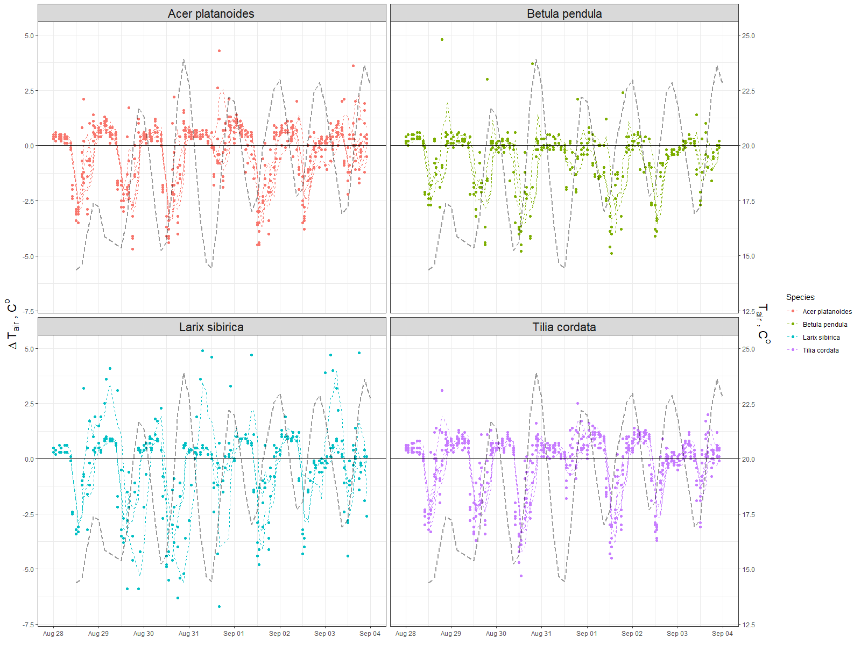

Annex 2. Daily and diurnal by month dynamics of the air relative humidity under and outside of the canopy

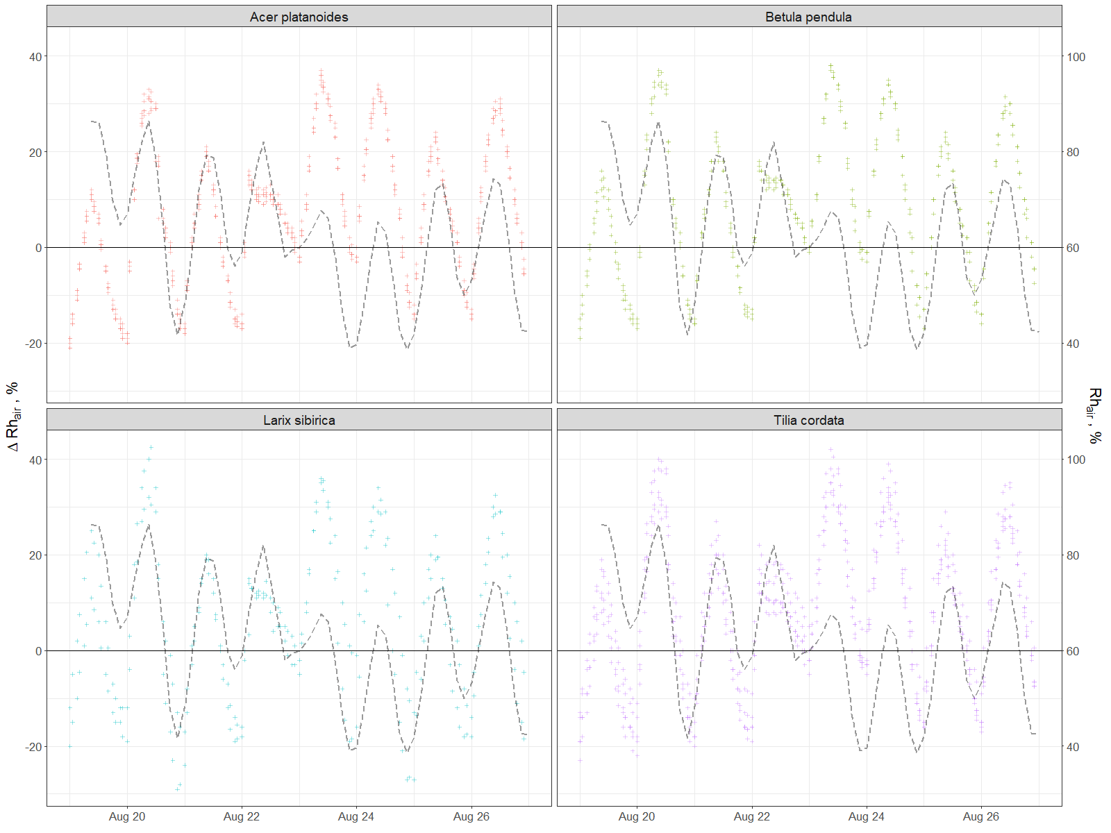

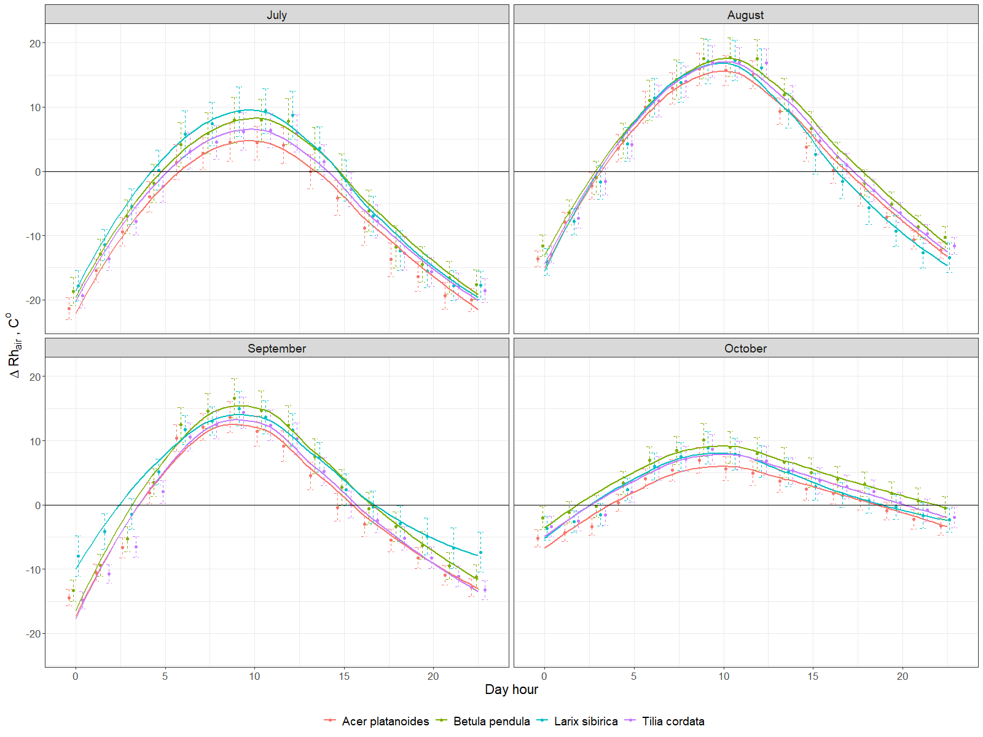

|  |  |  |  |  |  |  |  |  |  |  |  |  |  |  |  |  |  |  |  |  |  |  |  |
| --- | --- | --- | --- | --- | --- | --- | --- | --- | --- | --- | --- | --- | --- | --- | --- | --- | --- | --- | --- | --- | --- | --- | --- |
| **Annex 3. Tree description and summative of ecosystem services produced by each tree per investigated period (July-November,2019)** | | | | | | | | | | | | | | | | | | | | | | | |
|  | **Trees description** | | | | | | | | | | | **Biomass carbon** | | **Transpiration and precipitation** | | | **Energy asborbed** | **PM10 particles absorbed, g** | | | **Leaf and wood indexes** | | |
| **id** | **Age group** | **Tree height, m** | **Trunk diameter,cm** | **Trunk growth,mm** | **Canopy area, m2** | **VTA** | **BEF** | **BCEF** | **R/S** | **Total tree carbon, kg** | **Average annual tree carbon increment, kg** | **Carbon stored, kg** | **Carbon stored per canopy area, kg m-2** | **Transpiration, mm** | **Precipitation, mm** | **Ratio of precipitation evaporated, mm** | **L, kWh** | **PM10max** | **PM10avg** | **PM10min** | **PAI, m2m-2** | **WAI, m2m-2** | **LAI, m2m-2** |
| ***Acer platanoides*** | | | | | | | | | | | | | | | | | | | | | | | |
| **218A0077** | 50-60 | 20 | 35.65 | 3.36 | 55.7 | 2 | 1.31 | 1.05 | 0.317 | 580.02 | 10.55 | 12.95 | 0.23 | 83.59 | 183.5 | 0.46 | 2454 | 17976 | 11504 | 4494 | 4.81 | 0.47 | 4.34 |
| **218A0212** | 50-60 | 15 | 33.74 | 3.18 | 27.6 | 3 | 1.31 | 1.05 | 0.317 | 393.59 | 7.16 | 8.79 | 0.32 | 130.8 | 183.5 | 0.71 | 1615 | 7250 | 4640 | 1812 | 3.99 | 0.51 | 3.49 |
| **218A0255** | 50-60 | 20 | 34.38 | 3.24 | 55.3 | 2 | 1.31 | 1.05 | 0.317 | 559.75 | 10.18 | 12.5 | 0.23 | 92.1 | 183.5 | 0.5 | 2506 | 15065 | 9641 | 3766 | 4.26 | 0.42 | 3.84 |
| **218A0262** | 50-60 | 13 | 34.7 | 3.27 | 28.5 | 1 | 1.31 | 1.05 | 0.317 | 373.73 | 6.8 | 8.35 | 0.29 | 168.32 | 183.5 | 0.92 | 2739 | 7861 | 5031 | 1965 | 4.81 | 0.57 | 4.23 |
| **218A0281** | 50-60 | 14 | 45.84 | 4.32 | 35.8 | 4 | 1.31 | 1.05 | 0.317 | 684.96 | 12.45 | 15.3 | 0.43 | 190.09 | 183.5 | 1.04 | 3042 | 11940 | 7641 | 2985 | 3.64 | 0.43 | 3.21 |
| **Mean** |  | 16.8 | 36.86 | 3.47 | 40.58 |  |  |  |  | 518.41 | 9.43 | 11.58 | 0.3 | 132.98 | 183.5 | 0.72 | 2471.2 | 12019 | 7691.8 | 3004.6 | 4.30 | 0.48 | 3.82 |
| **SE** |  | 1.7 | 2.53 | 0.24 | 6.99 |  |  |  |  | 66.03 | 1.2 | 1.47 | 0.04 | 23.22 | 0 | 0.13 | 266 | 2302.1 | 1473.3 | 575.5 | 0.23 | 0.03 | 0.21 |
| ***Betula pendula*** | | | | | | | | | | | | | | | | | | | | | | | |
| **218A0104** | 50-60 | 11 | 21.65 | 2.72 | 7.6 | 1 | 1.19 | 0.761 | 0.219 | 80.41 | 1.46 | 2.39 | 0.31 | 242.16 | 183.5 | 1.32 | 1157 | 2029 | 1298 | 507 | 3.95 | 0.44 | 3.51 |
| **218A0210** | 30-40 | 11 | 21.01 | 2.64 | 6.4 | 1 | 1.19 | 0.761 | 0.219 | 73.7 | 1.34 | 2.19 | 0.34 | 304.4 | 183.5 | 1.66 | 1226 | 2046 | 1309 | 511 | 4.02 | 0.42 | 3.6 |
| **218A0285** | 30-40 | 11 | 23.87 | 3 | 8.2 | 1 | 1.19 | 0.761 | 0.219 | 93.85 | 1.71 | 2.79 | 0.34 | 340.33 | 183.5 | 1.85 | 1756 | 2468 | 1579 | 617 | 4.11 | 0.42 | 3.69 |
| **Mean** |  | 11 | 22.18 | 2.79 | 7.4 |  |  |  |  | 82.65 | 1.5 | 2.46 | 0.33 | 295.63 | 183.5 | 1.61 | 1379.4 | 2181.2 | 1396 | 545.3 | 4.03 | 0.43 | 3.60 |
| **SE** |  | 0 | 7 | 0.91 | 0.55 |  |  |  |  | 8.34 | 0.15 | 0.39 | 0.1 | 100.49 | 0 | 0.55 | 436.7 | 149.8 | 95.9 | 37.4 | 0.05 | 0.00 | 0.05 |
| ***Larix sibirica*** | | | | | | | | | | | | | | | | | | | | | | | |
| **218A0079** | 80-100 | 25 | 32.15 | 2.02 | 65.9 | 3 | 1.13 | 0.754 | 0.326 | 421.11 | 7.66 | 6.28 | 0.1 | 41.04 | 183.5 | 0.22 | 1701 | 17527 | 11218 | 4382 | 4.71 | 0.80 | 3.91 |
| **218A0138** | 80-100 | 19 | 40.74 | 2.56 | 37.4 | 2 | 1.13 | 0.754 | 0.326 | 519.51 | 9.45 | 7.75 | 0.21 | 137.62 | 183.5 | 0.75 | 3238 | 9824 | 6288 | 2456 | 4.08 | 0.46 | 3.62 |
| **218A0277** | 80-100 | 24 | 26.1 | 1.64 | 32.3 | 2 | 1.13 | 0.754 | 0.326 | 272.47 | 4.95 | 4.06 | 0.13 | 72.88 | 183.5 | 0.4 | 1481 | 8805 | 5635 | 2201 | 4.01 | 0.37 | 3.64 |
| **Mean** |  | 22.7 | 33 | 2.07 | 45.2 |  |  |  |  | 404.36 | 7.35 | 6.03 | 0.14 | 83.85 | 183.5 | 0.46 | 2140 | 12053 | 7713.6 | 3013.1 | 4.27 | 0.54 | 3.72 |
| **SE** |  | 2.2 | 5.2 | 0.33 | 12.8 |  |  |  |  | 87.94 | 1.6 | 1.31 | 0.04 | 34.8 | 0 | 0.19 | 676.9 | 3372.1 | 2158.1 | 843 | 0.22 | 0.10 | 0.09 |
| ***Tilia cordata*** | | | | | | | | | | | | | | | | | | | | | | | |
| **218A0111** | 50-60 | 12 | 28.01 | 5.28 | 20 | 3 | 1.16 | 0.682 | 0.282 | 137.55 | 2.5 | 6.12 | 0.31 | 174.45 | 183.5 | 0.95 | 2195 | 6454 | 4131 | 1613 | 4.31 | 0.53 | 3.78 |
| **218A0121** | 50-60 | 17 | 37.88 | 7.14 | 31.3 | 1 | 1.16 | 0.682 | 0.282 | 345 | 6.27 | 15.34 | 0.49 | 171.14 | 183.5 | 0.93 | 3370 | 6708 | 4293 | 1677 | 4.59 | 0.56 | 4.03 |
| **218A0153** | 40-50 | 14 | 35.33 | 6.66 | 21.1 | 2 | 1.16 | 0.682 | 0.282 | 245.59 | 4.47 | 10.92 | 0.52 | 165.41 | 183.5 | 0.9 | 2196 | 5405 | 3459 | 1351 | 4.44 | 0.42 | 4.02 |
| **218A0186** | 40-50 | 17 | 40.43 | 7.62 | 19.5 | 3 | 1.16 | 0.682 | 0.282 | 400.09 | 7.27 | 17.79 | 0.91 | 175.42 | 183.5 | 0.96 | 2152 | 4893 | 3131 | 1223 | 3.8 | 0.40 | 3.4 |
| **218A0270** | 30-40 | 11 | 25.15 | 4.74 | 22.4 | 3 | 1.16 | 0.664 | 0.272 | 96.81 | 1.76 | 4.3 | 0.19 | 84.88 | 183.5 | 0.46 | 1196 | 6478 | 4146 | 1619 | 4.44 | 0.48 | 3.95 |
| **Mean** |  | 14.1 | 33.36 | 6.29 | 22.86 |  |  |  |  | 245.01 | 4.45 | 10.89 | 0.48 | 154.26 | 183.5 | 0.84 | 2221.7 | 5987.6 | 3832 | 1496.9 | 4.32 | 0.48 | 3.84 |
| **SE** |  | 1.3 | 3.26 | 0.61 | 2.42 |  |  |  |  | 64.98 | 1.18 | 2.89 | 0.14 | 19.49 | 0 | 0.11 | 385.4 | 396.4 | 253.7 | 99.1 | 0.14 | 0.03 | 0.12 |

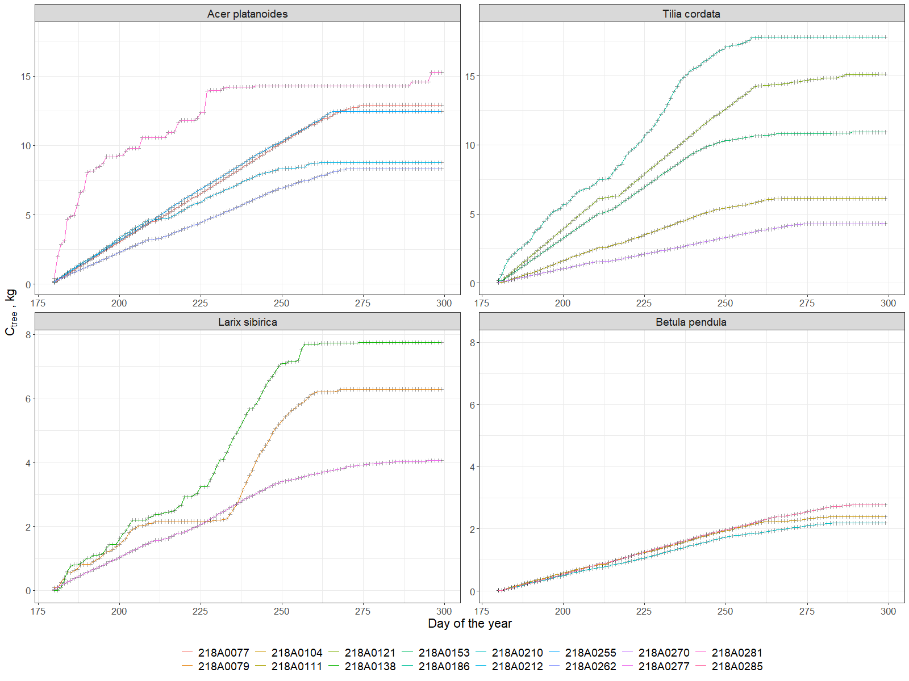

Annex 4. Cumulative grow of stored carbon for each tree.

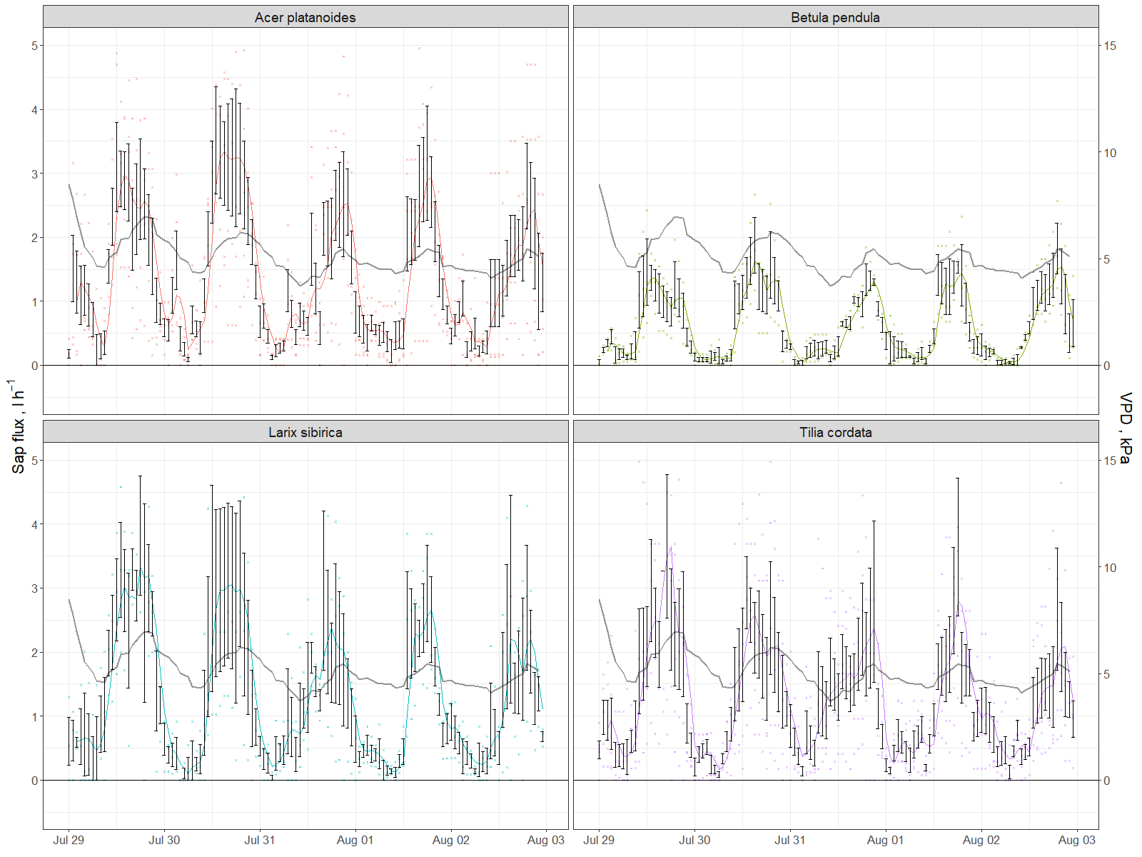

Annex 5. Example of flux dynamics per species for several days

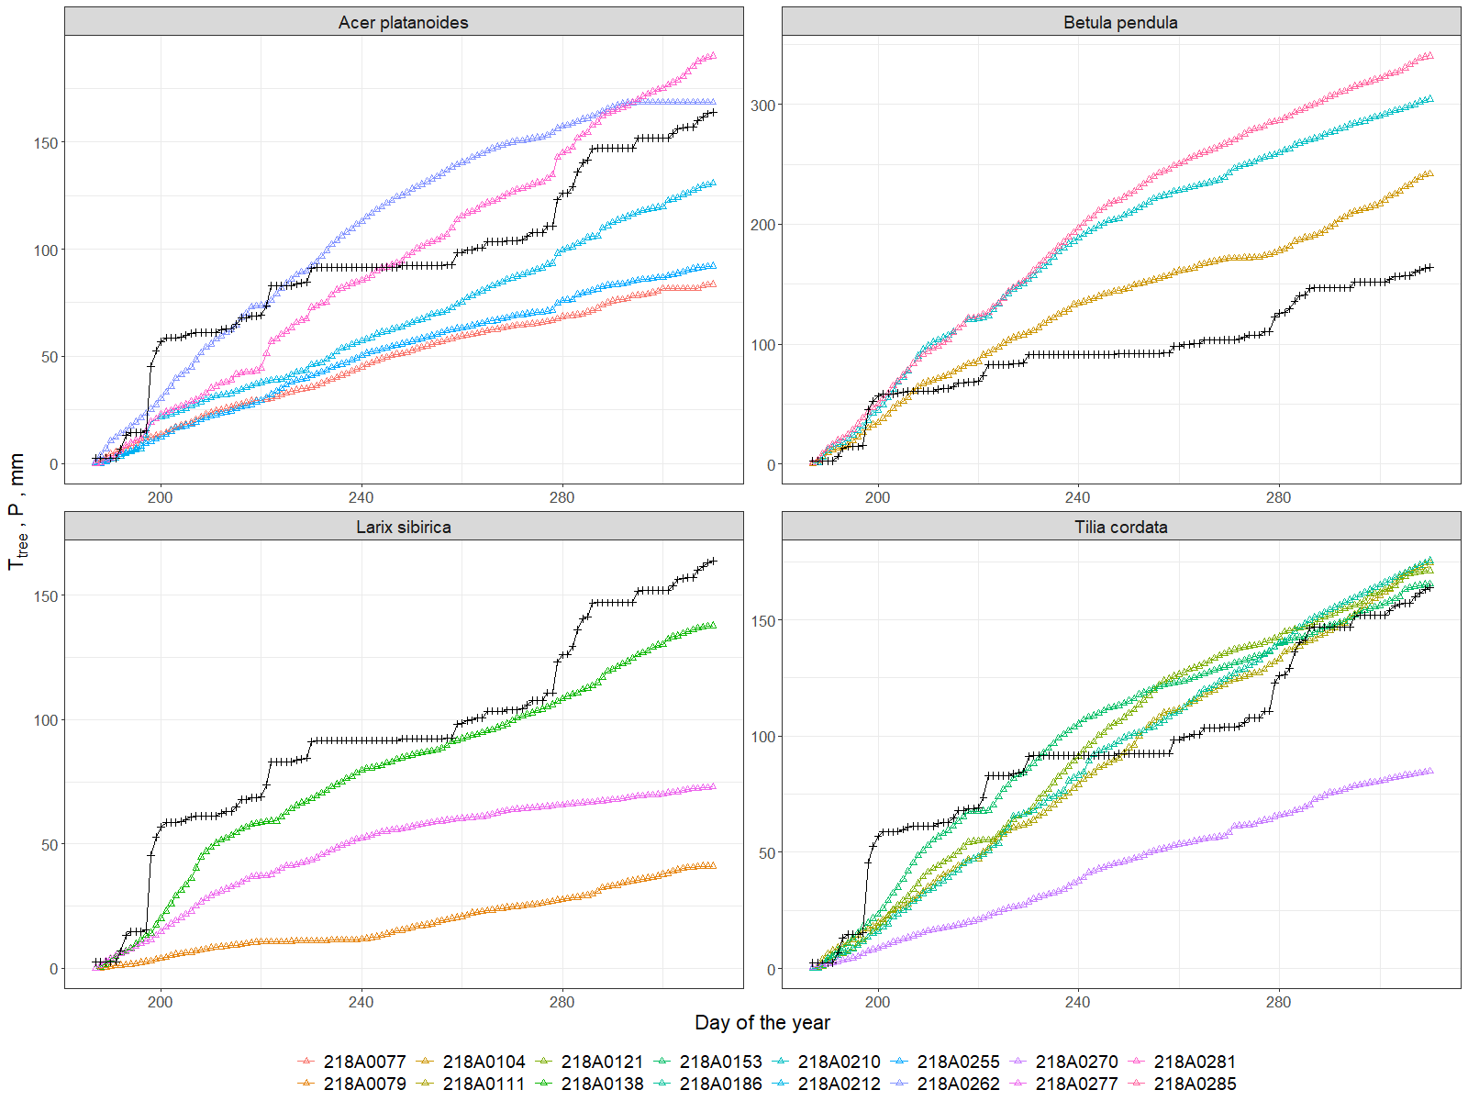

Annex 6.Transpiration of each tree compared to precipitation (black line).

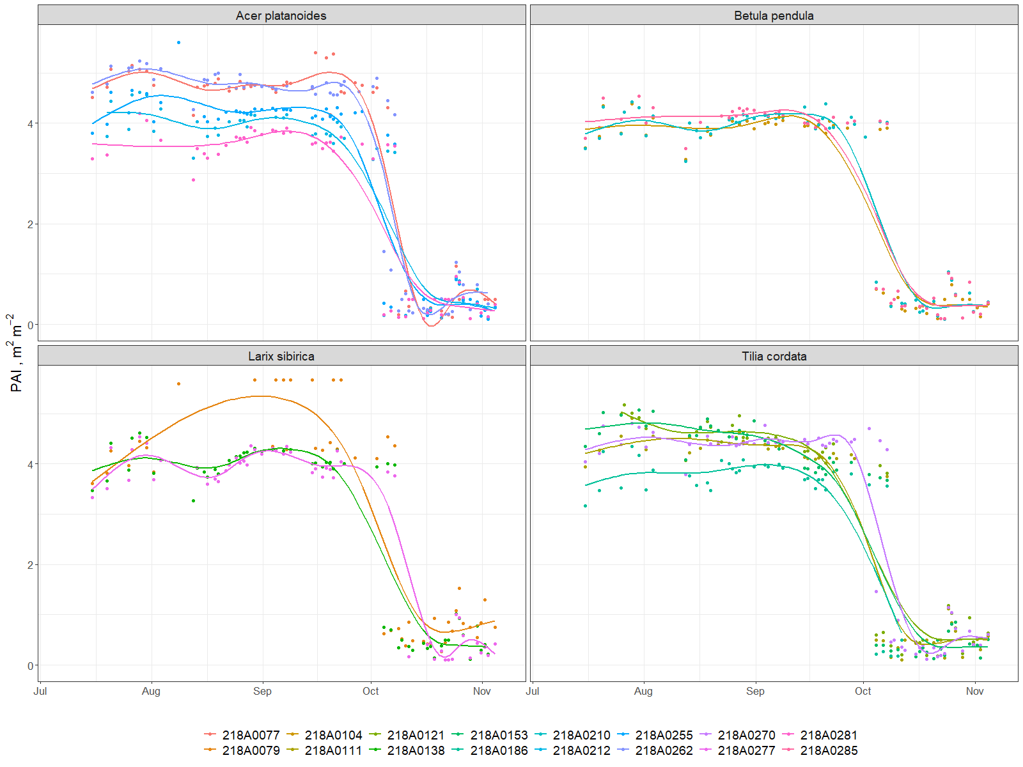

Annex 7. PAI dynamics during investigated period (July-November, 2019)

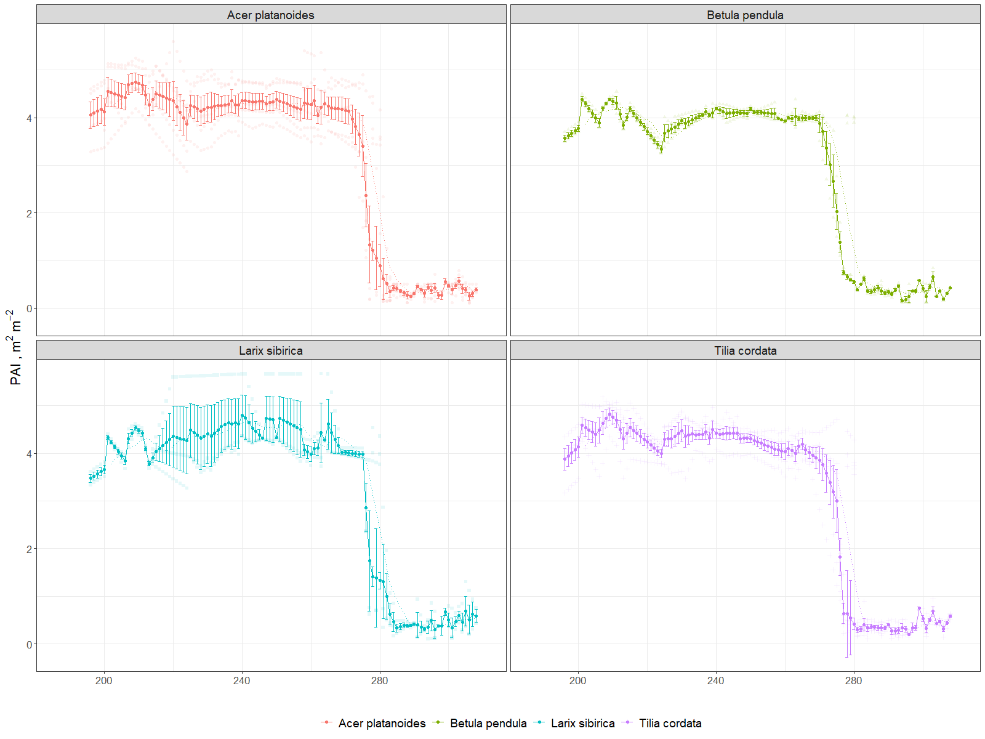Annex 6. PAI dynamics per species during investigated period (July-November, 2019)